**SCREENSHOTS FOR ETHNUS AWS WEBINAR- BUILDING A FACE DETECTION APPLICATION USING AWS (AMAZON WEB SERVICES)**

**AAKASH RAMAN**

I have uploaded more than 25 screenshots according to each day. This was done for my better understanding. Some description is also added for each screenshot.

**Day-4 (EC2):**

1. Choosing EC2 from Services

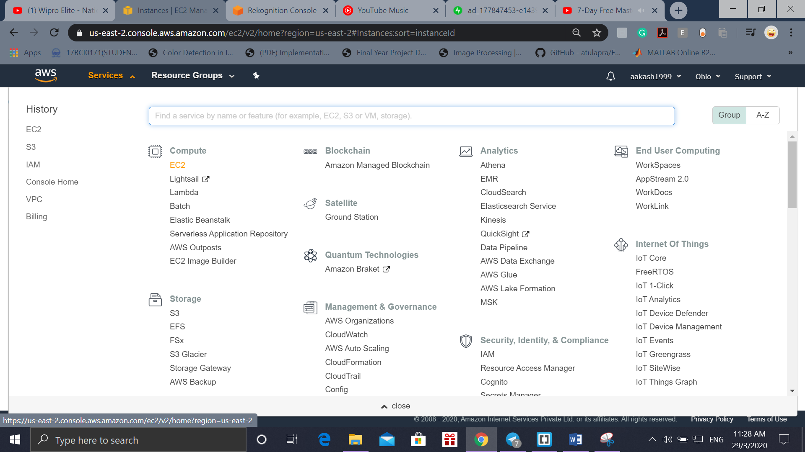

1. EC2 Dashboard

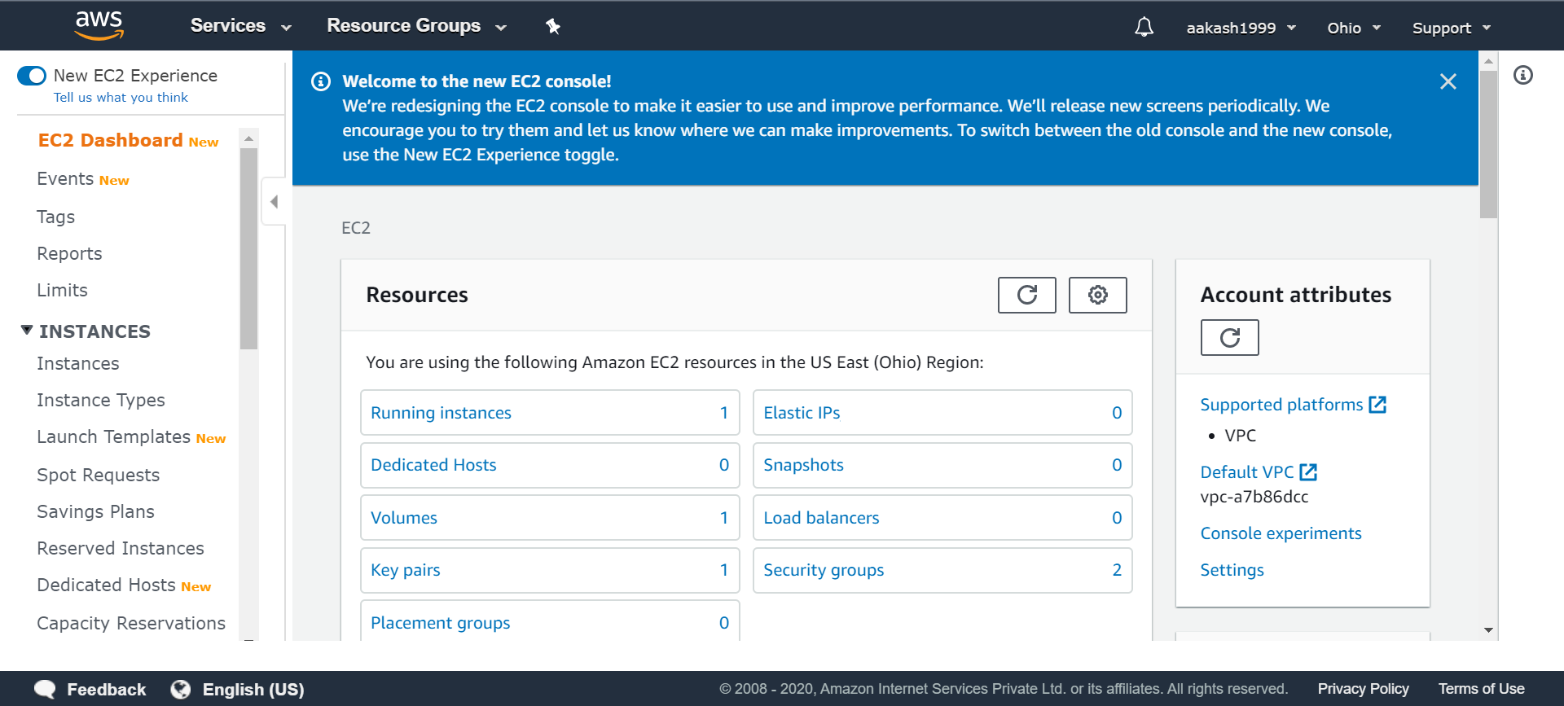

1. Launching Instances from US (Ohio) region

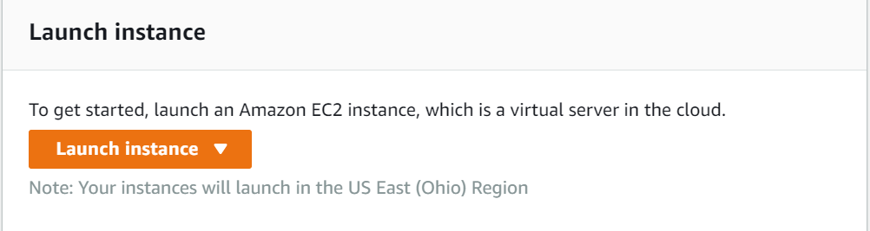

1. Choosing the Operating System-Amazon Machine Image (Free Tier)

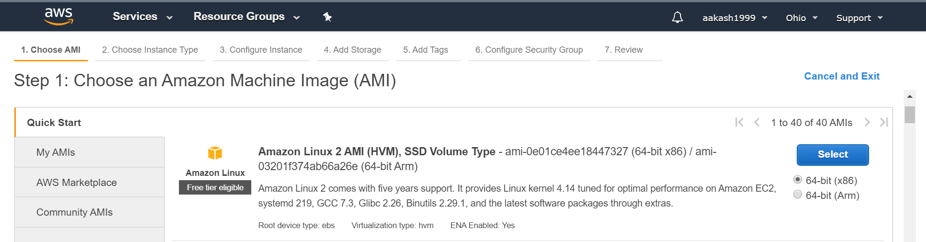

1. Choosing the Instance Type- General purpose(t2-micro with 1 vCPU and 1 GiB)

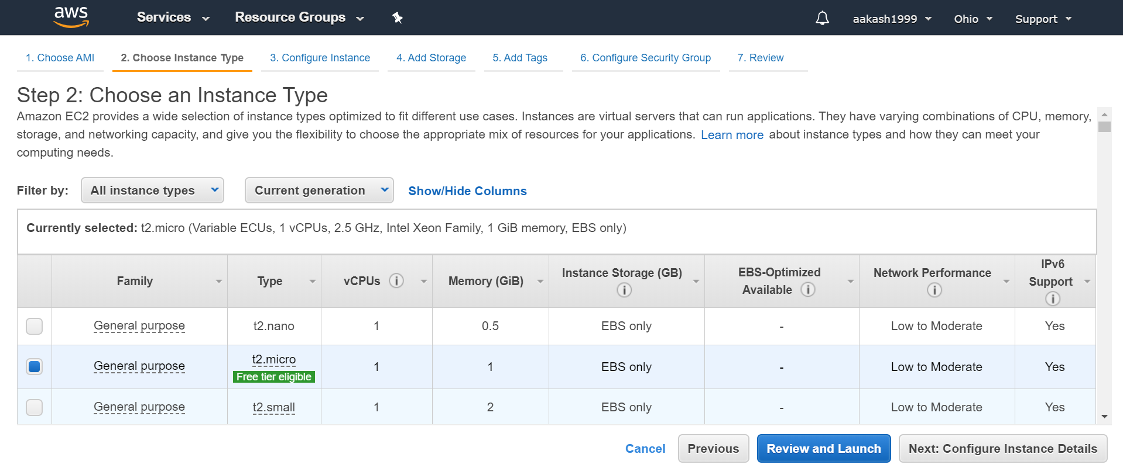

1. Configuring the Instance details leaving it as it is

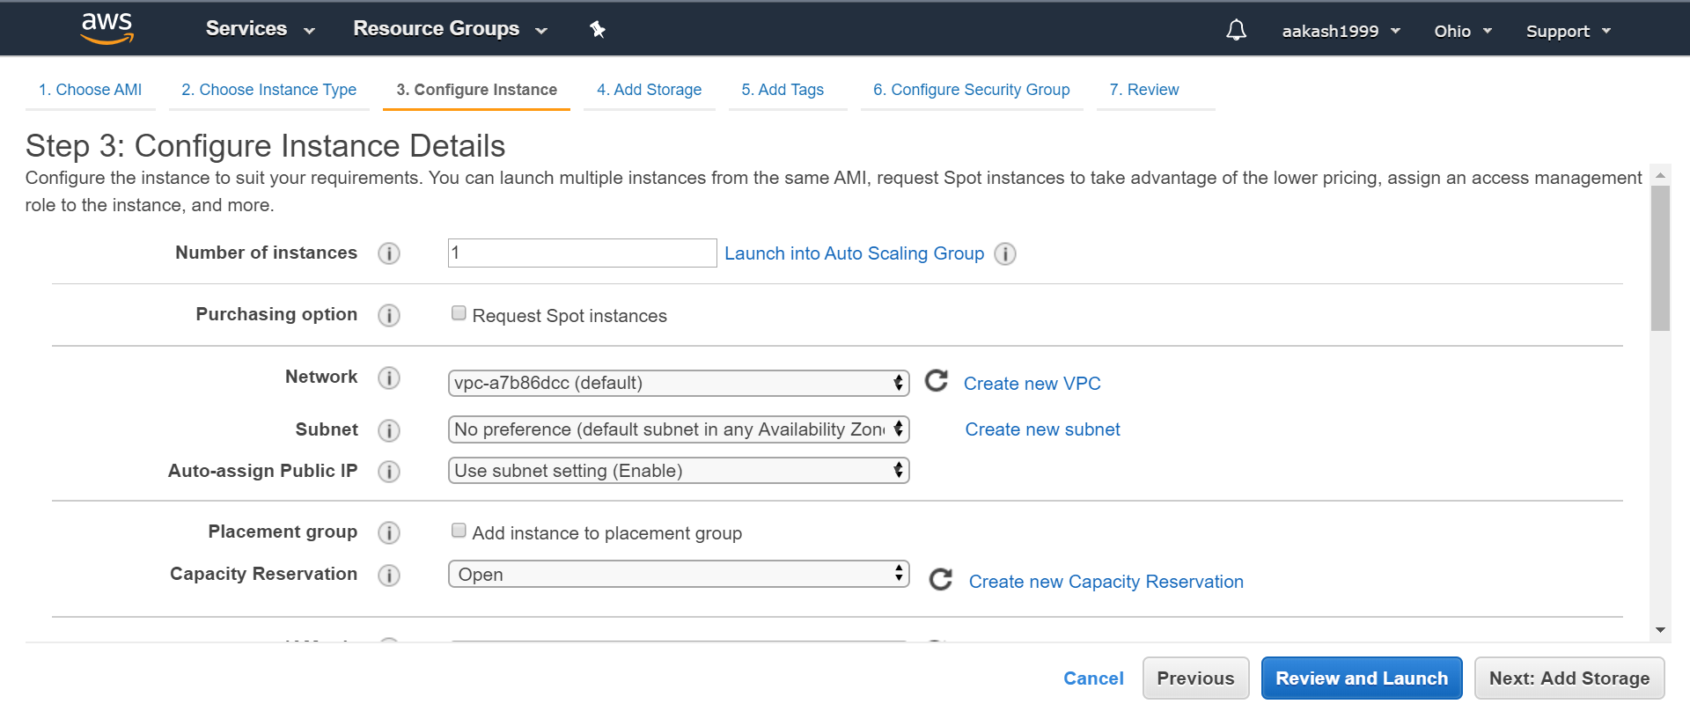

1. Choosing the memory-8 GB and General Purpose SSD’s

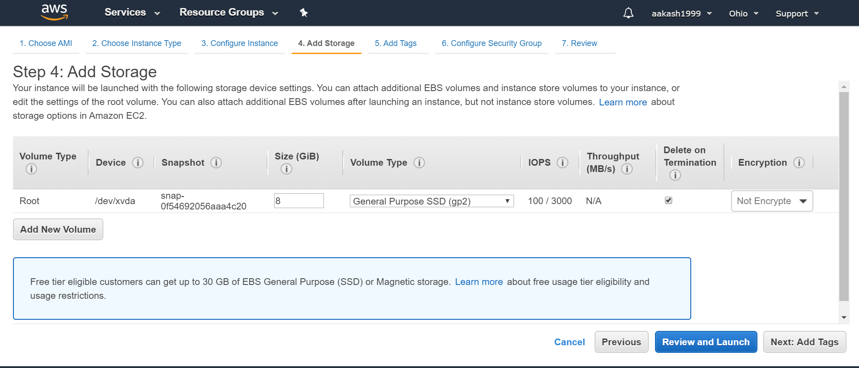

1. Adding Tags

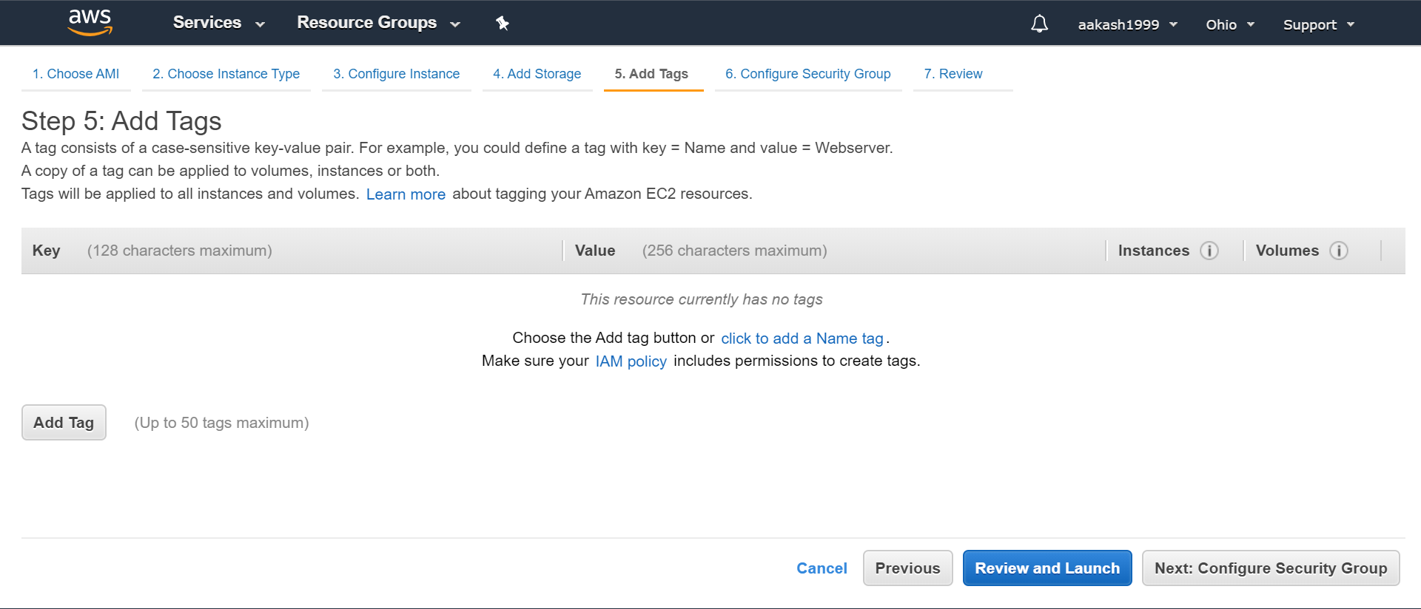

1. Customizable Security Groups

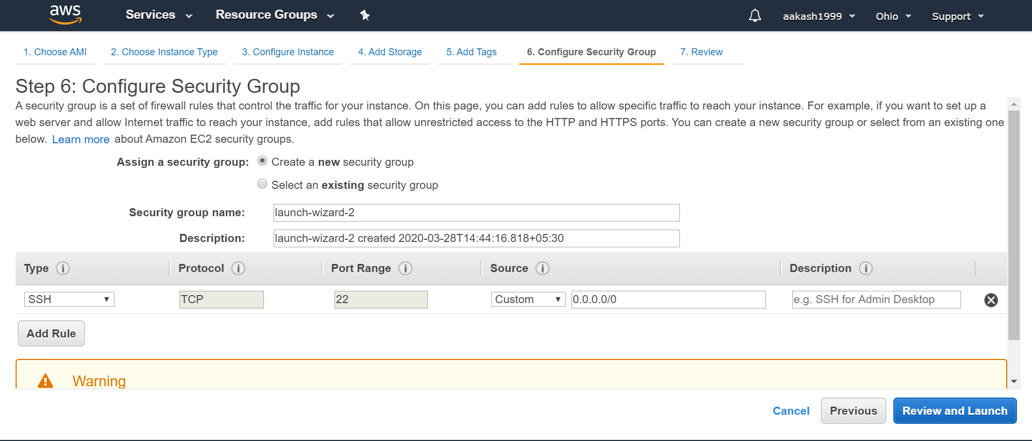

1. Reviewing the Instance Launch

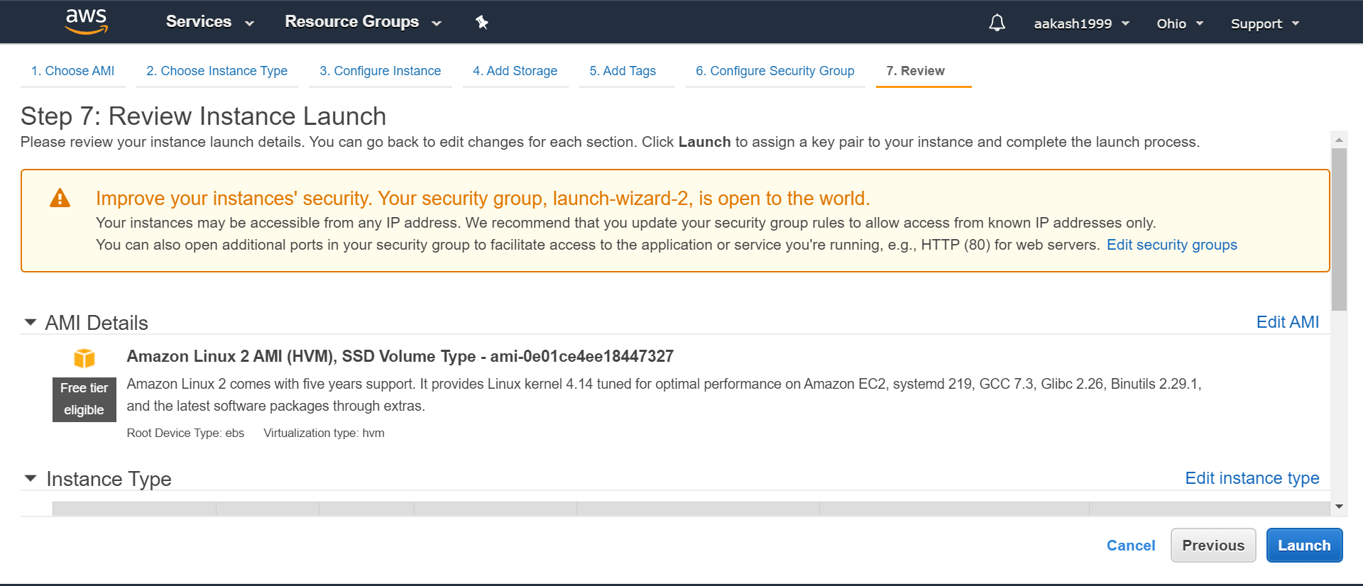

1. Creating a new key pair in (.PEM) format

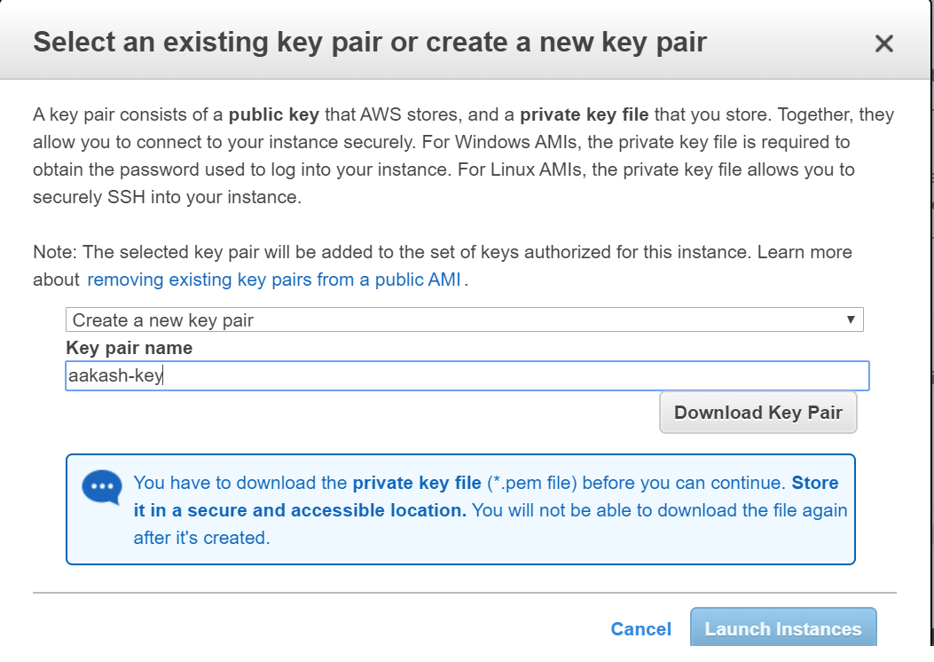

1. After choosing the key pair, the instance is launched as shown below.

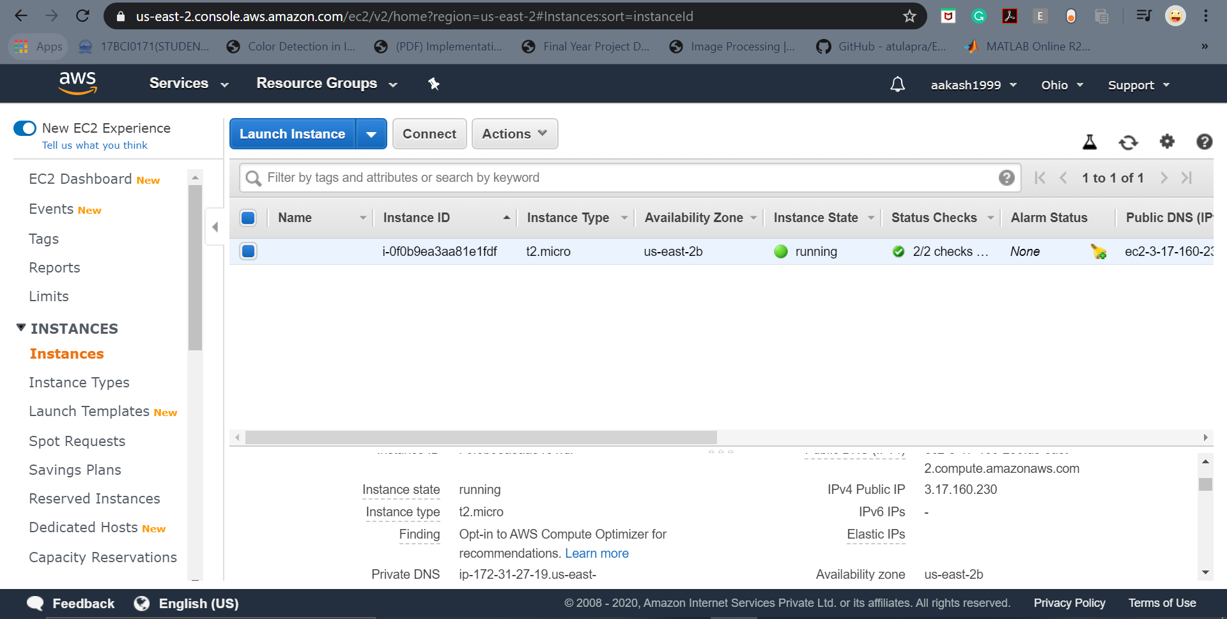

The IP Address for me is “***3.17.160.230***”.

But when I load the page nothing is shown.

1. Now we need to connect the server to the virtual machine. So, we use a tool called PuTTY. PuTTY accepts keys in the **“.PPK”** format. Hence we need to convert the “.PEM” file to “.PPK”. This is done by PuttyGen or by commands.

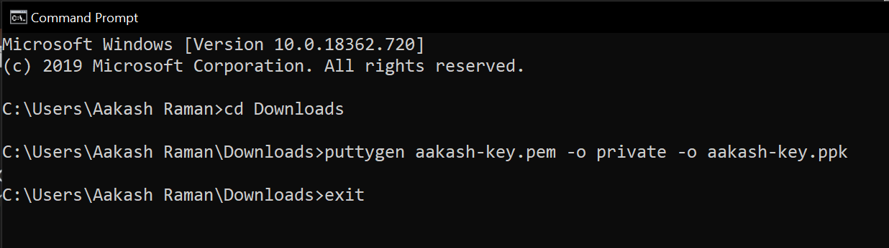



This is my key in .ppk format.

1. Now I have already downloaded PuTTY and entered my IP address along with the port.

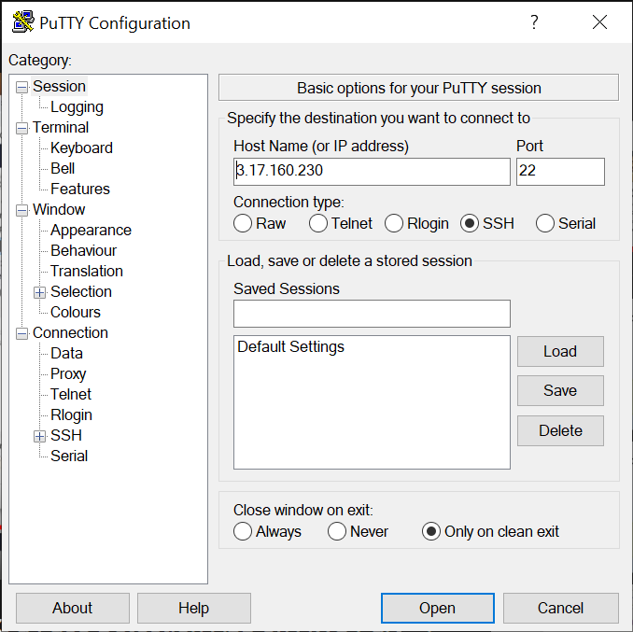

1. Next open up SSH and choose Auth where we choose the private key in .PPK format as shown below and click on Open.

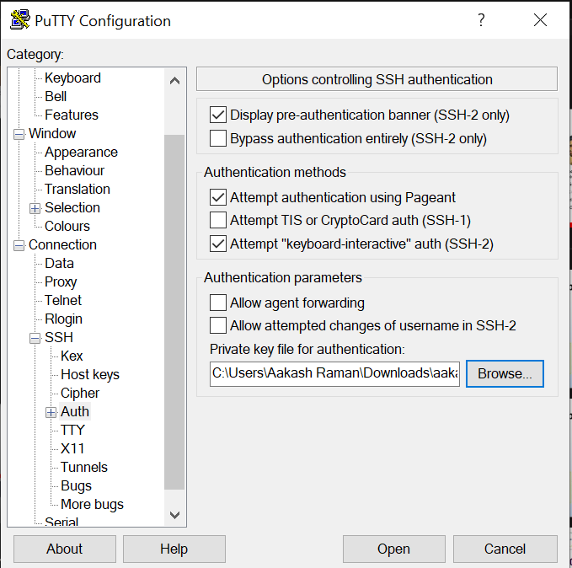

1. Now another window (command line interface) will open and we must Log In. The Login details will be “***ec2-user***” for our OS(Linux).

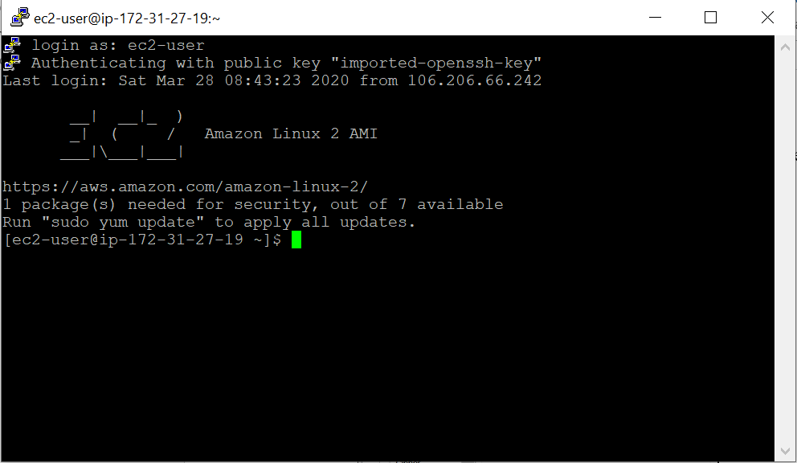

1. Now we need to install a service for our server on the virtual machine. This requires few commands that are given below. Write the commands in order on the command line.

*i)sudo yum install httpd- I have already installed this* (Run this command and press “y” [Yes])

*ii)sudo service httpd start*



*iii)sudo service httpd status*

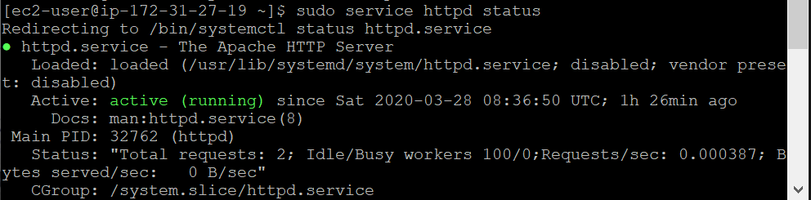

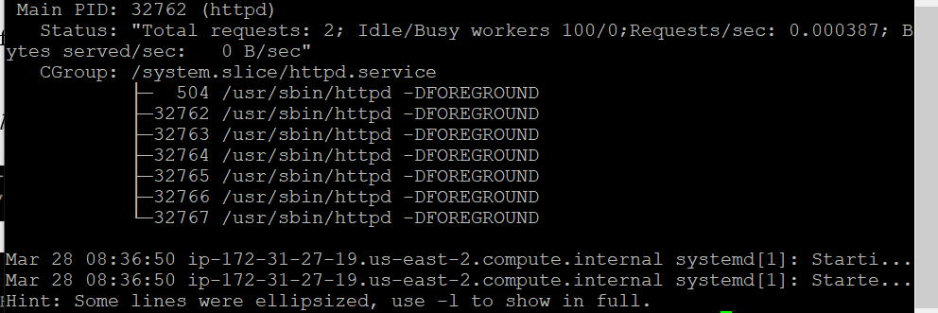

***Only if the status is active:running can we proceed.***

*iv)sudo vim /var/www/html/index.html*



*This command opens a blank page where one must press “i” to insert a line. Write whatever you want and then press* ***“:wq” then Enter****. You will be redirected to the same command line interface.*

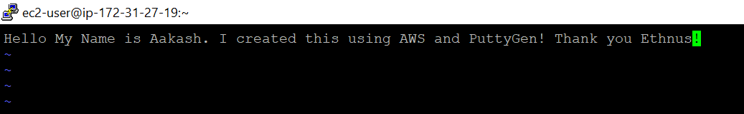

1. Our server only accepts SSH packets, hence we must add HTTP protocol as well. Hence, we need to enable our virtual machine to configure HTTP as well.

So, by clicking on Security Groups option below in AWS, we choose the “view inbound rules” option.

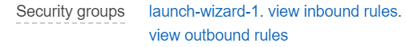

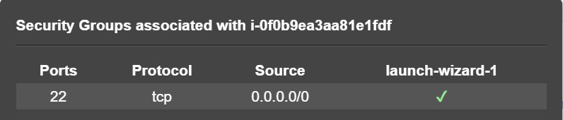

Only for SSH the rules are present. Hence, we need to add this for HTTP as well.

1. To do this click on Launch-wizard-1 present in security groups, then click on security group ID. In this page itself the inbound rules can be seen.

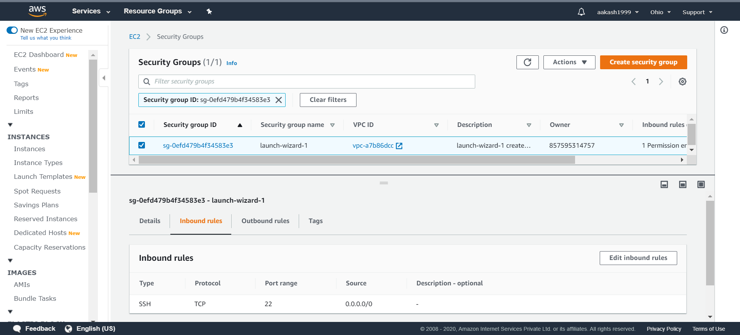

1. Then click on Edit Inbound Rules after which click on Add Rule and choose HTTP, the port range is chosen automatically and select the source to Anywhere so that anyone from any part of the world can access the website. Then click on Save Rules.

If the rules is successfully implemented a success message is received.

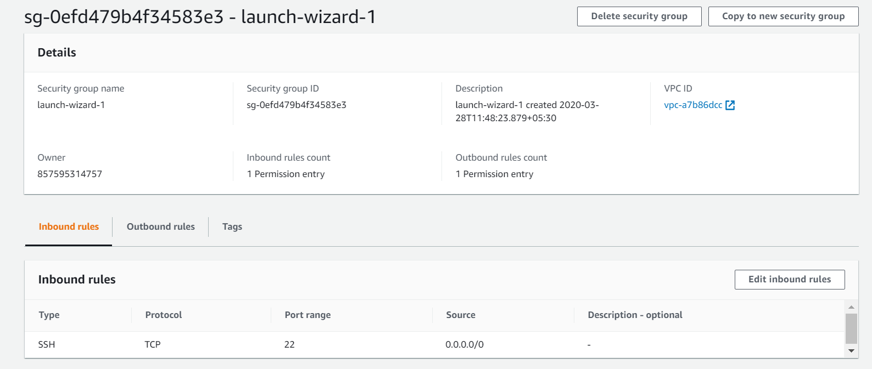

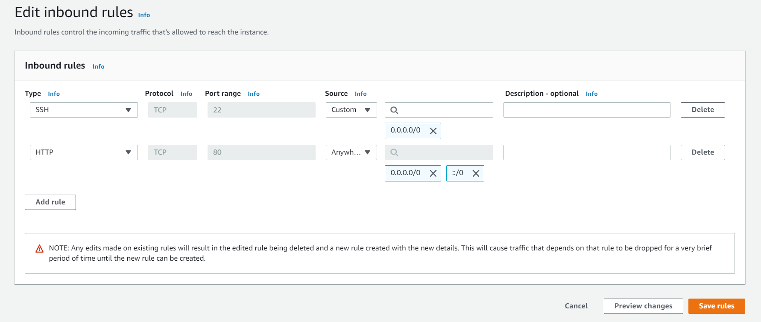

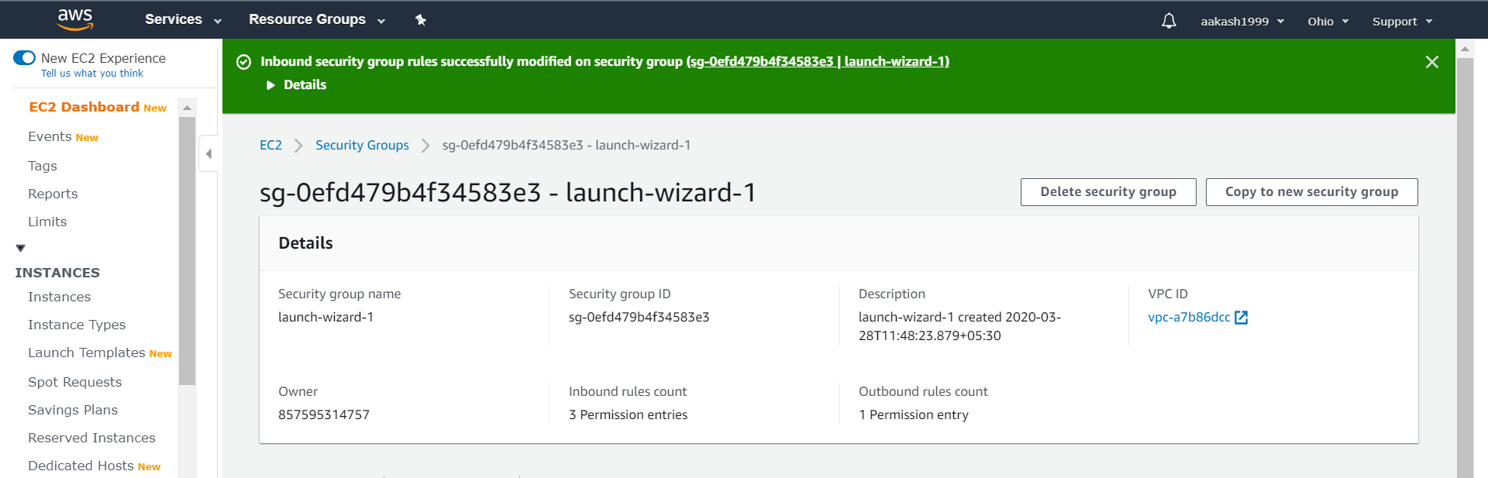

1. Next launch the website with the IP address **[3.17.160.230]** (My IP Address). What is seen is what we wrote in PuTTY.

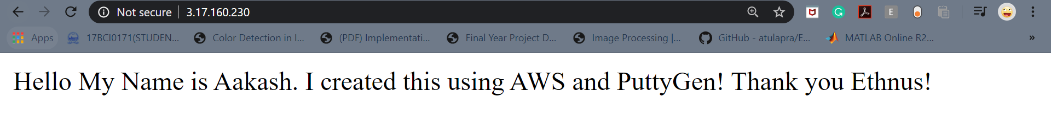

**Day-5(S3):**

1. In order to see what actions that are possible, select the instance go to actions and then choose stop, reboot or terminate.

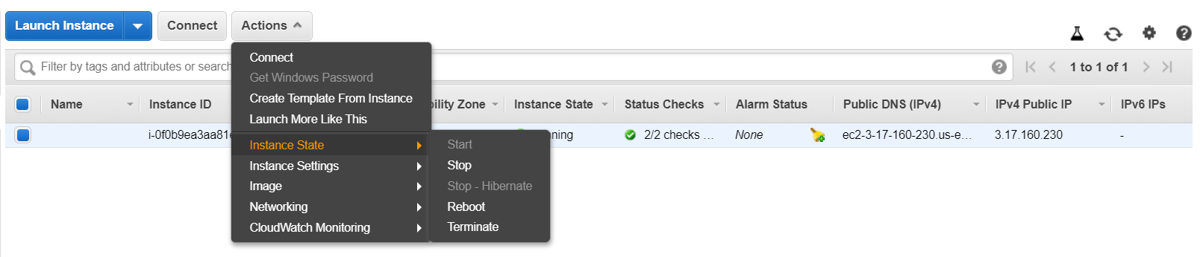

**Stop**-The machine is shut down and AWS Billing is stopped.

**Reboot**-Restarting the machine but the AWS Billing will be continued.

**Terminating**-Stop instance and also cannot start instance, the instance is lost.

1. Warning message when terminating instance.

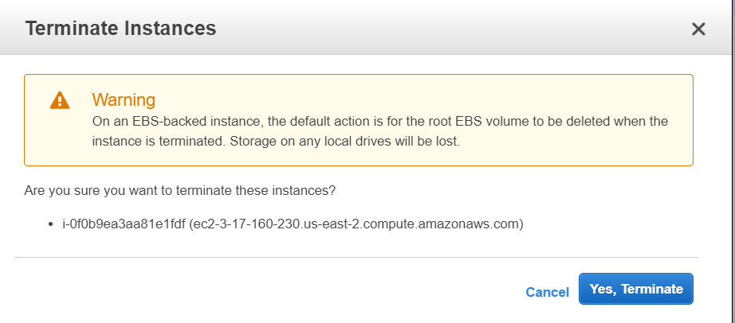

1. Choosing S3 from the Services

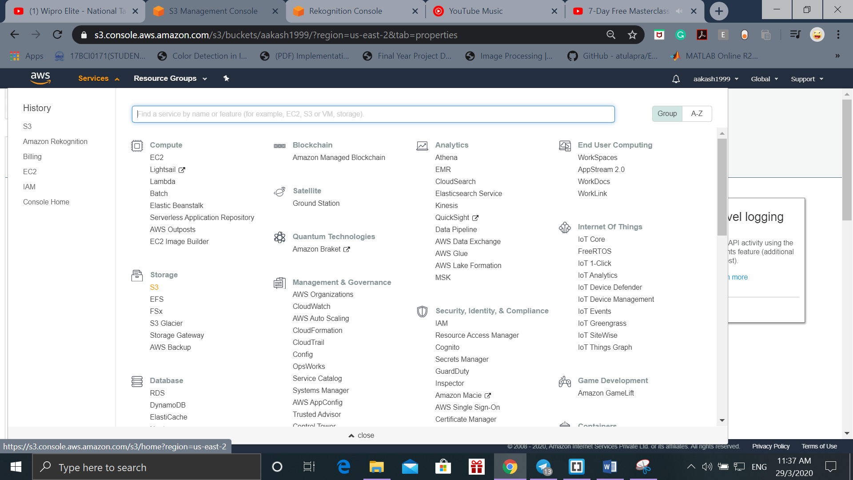

1. We need to create a Bucket(container of objects) and so click on Create Bucket option.

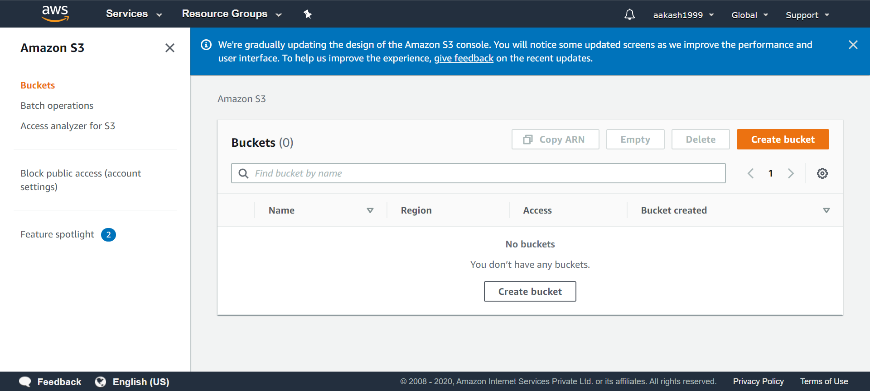

1. We can put the Bucket Name and choose the same region. In my case it is Ohio and click on Create Bucket.

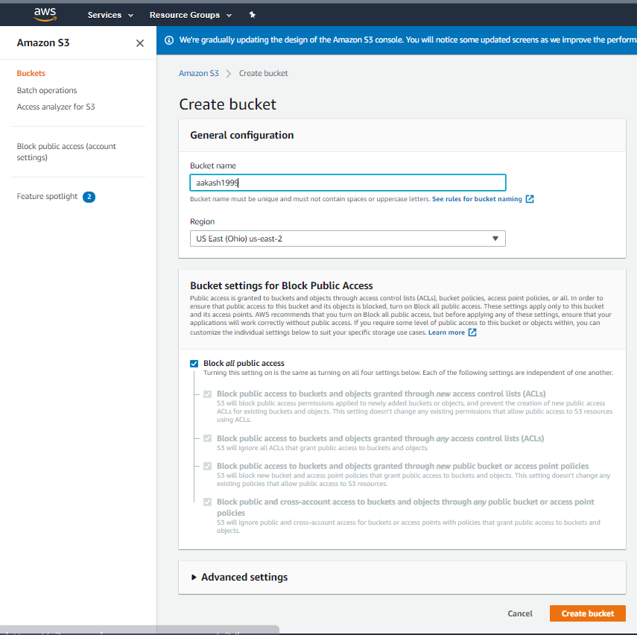

1. The Bucket is created for me. Bucket name must be unique for all individuals. ***S3 as a service doesn’t need a region to be selected whereas a bucket inside S3 as a service needs a region to be selected.***

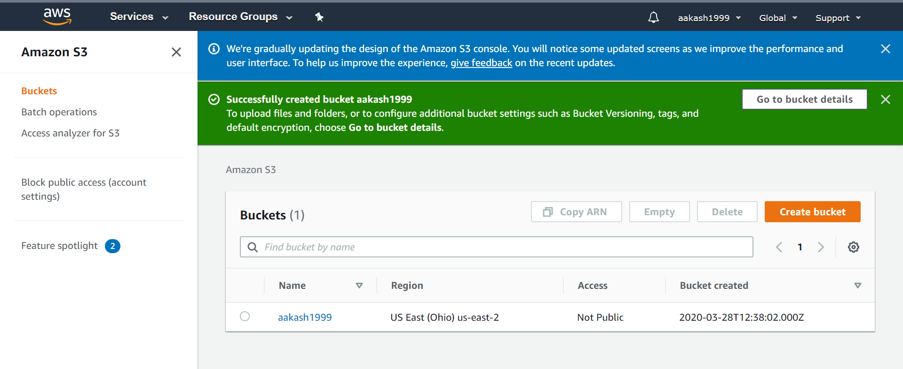

1. Now we need to upload a new object(file) inside the bucket. Click on the bucket name for this. Click on Upload and upload any HTML file. Make sure the S3 Tiring is in Standard.

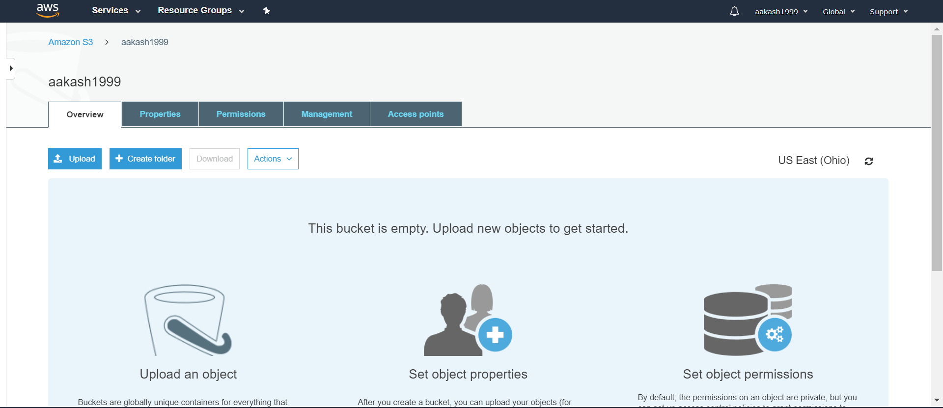

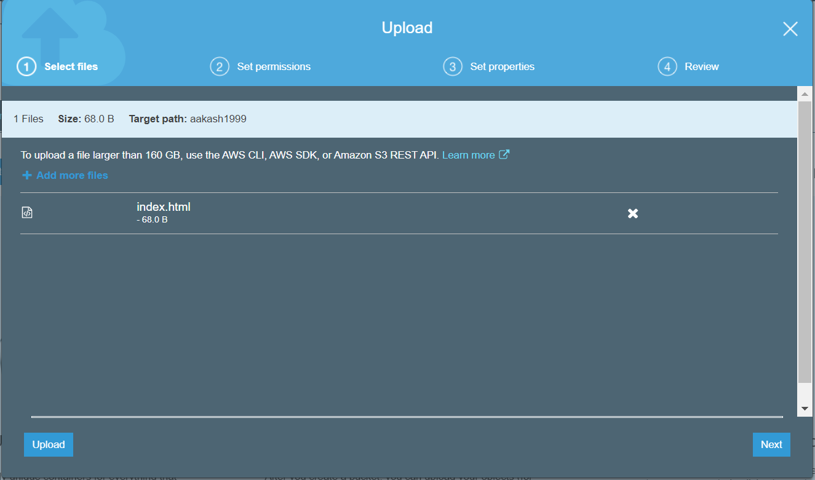

All other cases click on Next.

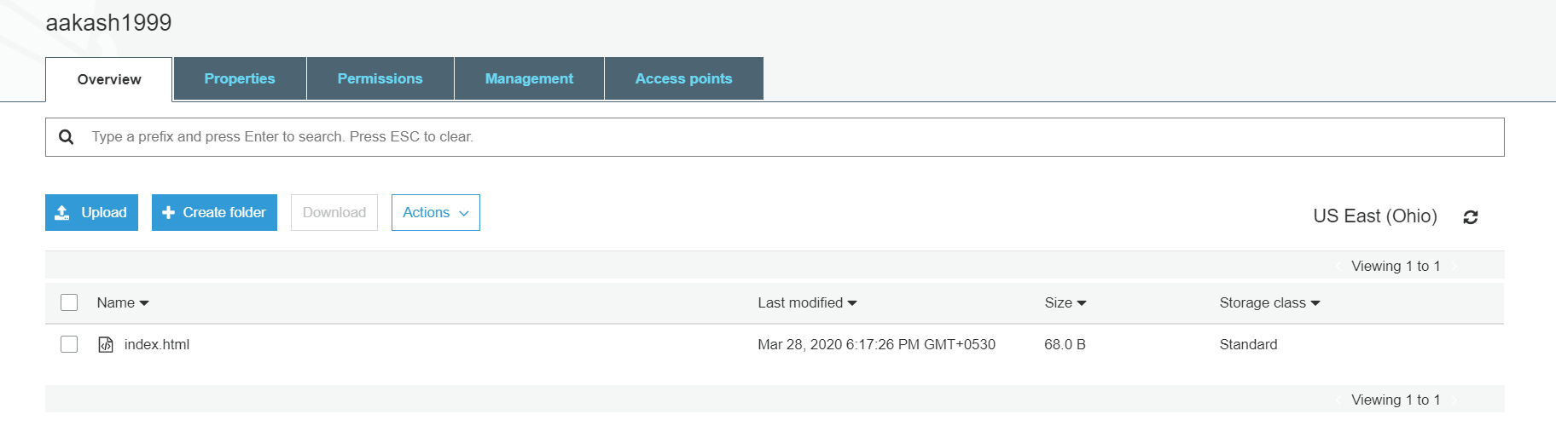

Now the file is uploaded.

1. By clicking on the file, properties about the object are found. The key of a bucket is always unique. These are the metadata (data about data) associated with the object.

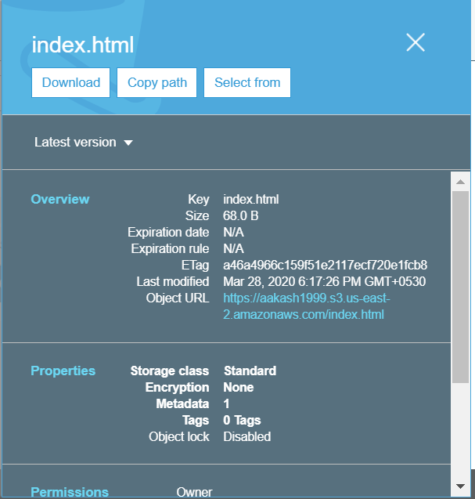

There are other metadata’s also associated with the file.

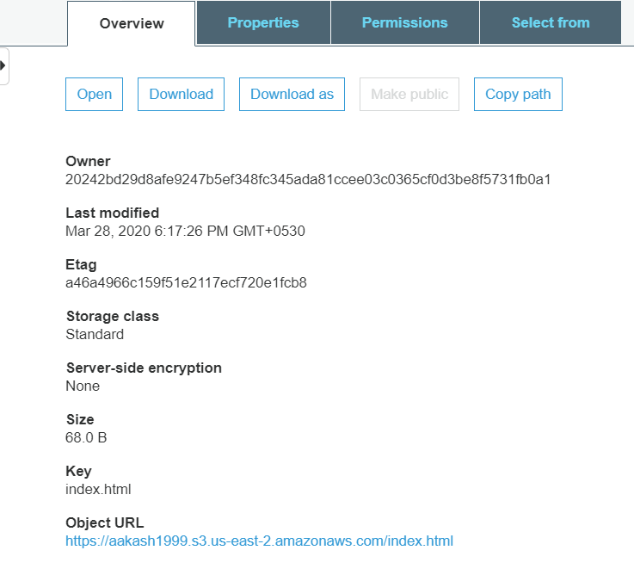

1. By clicking on the Object URL, we cannot access the data hence we need to make it public.

Hence S3 is secured.

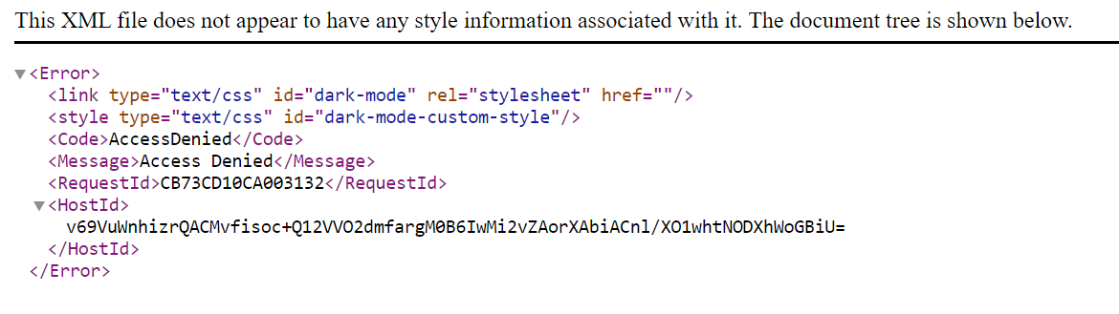

1. To download the file just click on Download. The file is as follows:

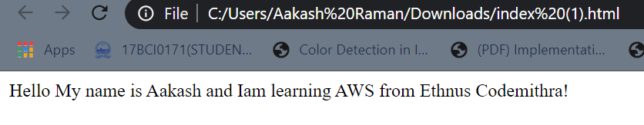

1. Next we visit the Infrastructure of AWS from “<https://infrastructure.aws/>”

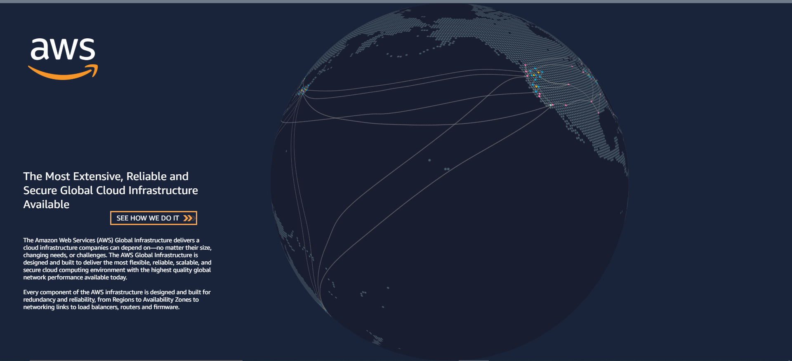

***A region is a geographical location where Amazon has all their physical data servers.***

***An availability zone is inside a region. Availability zone is the actual area where the data centres are located, they are apart from each other in most cases. They are required to increase the network availability of the region. Hence in a region at least 2 availability zones are present.***

***Edge locations are used for caching files.***

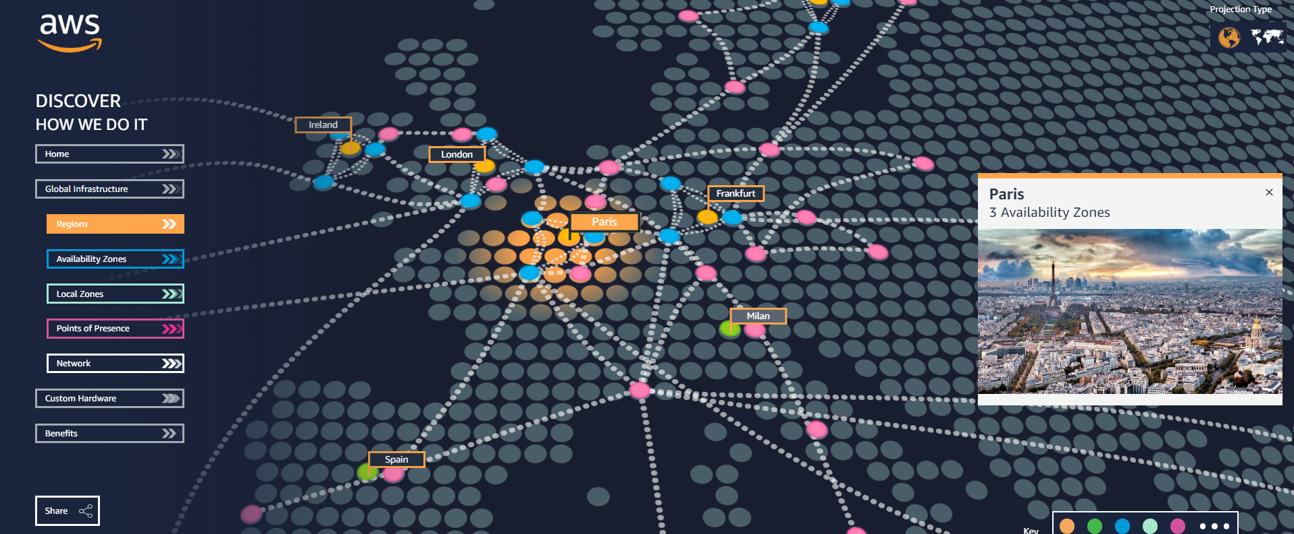

1. Subnets can be created in availability zones. Ever region has a VPC (Virtual Private Cloud) and also few subnets.
2. The different S3 Tiers for each bucket is also shown when we upload a file onto the bucket.

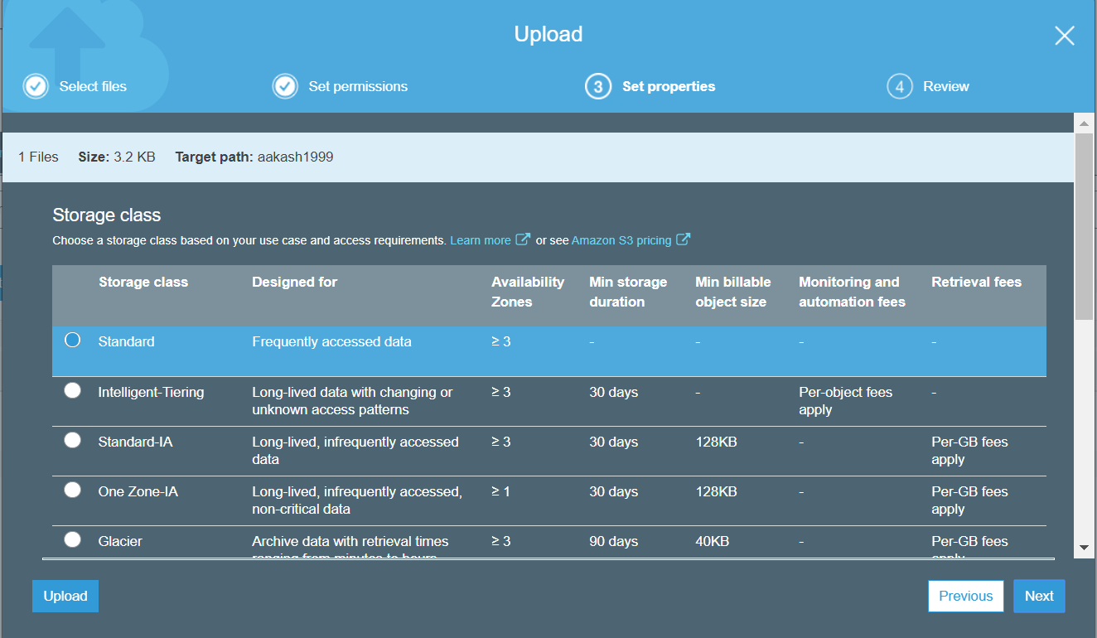

1. In order to enable the bucket for static web hosting, go to Properties and choose Static Web Hosting and enter the HTML file and click on Save.

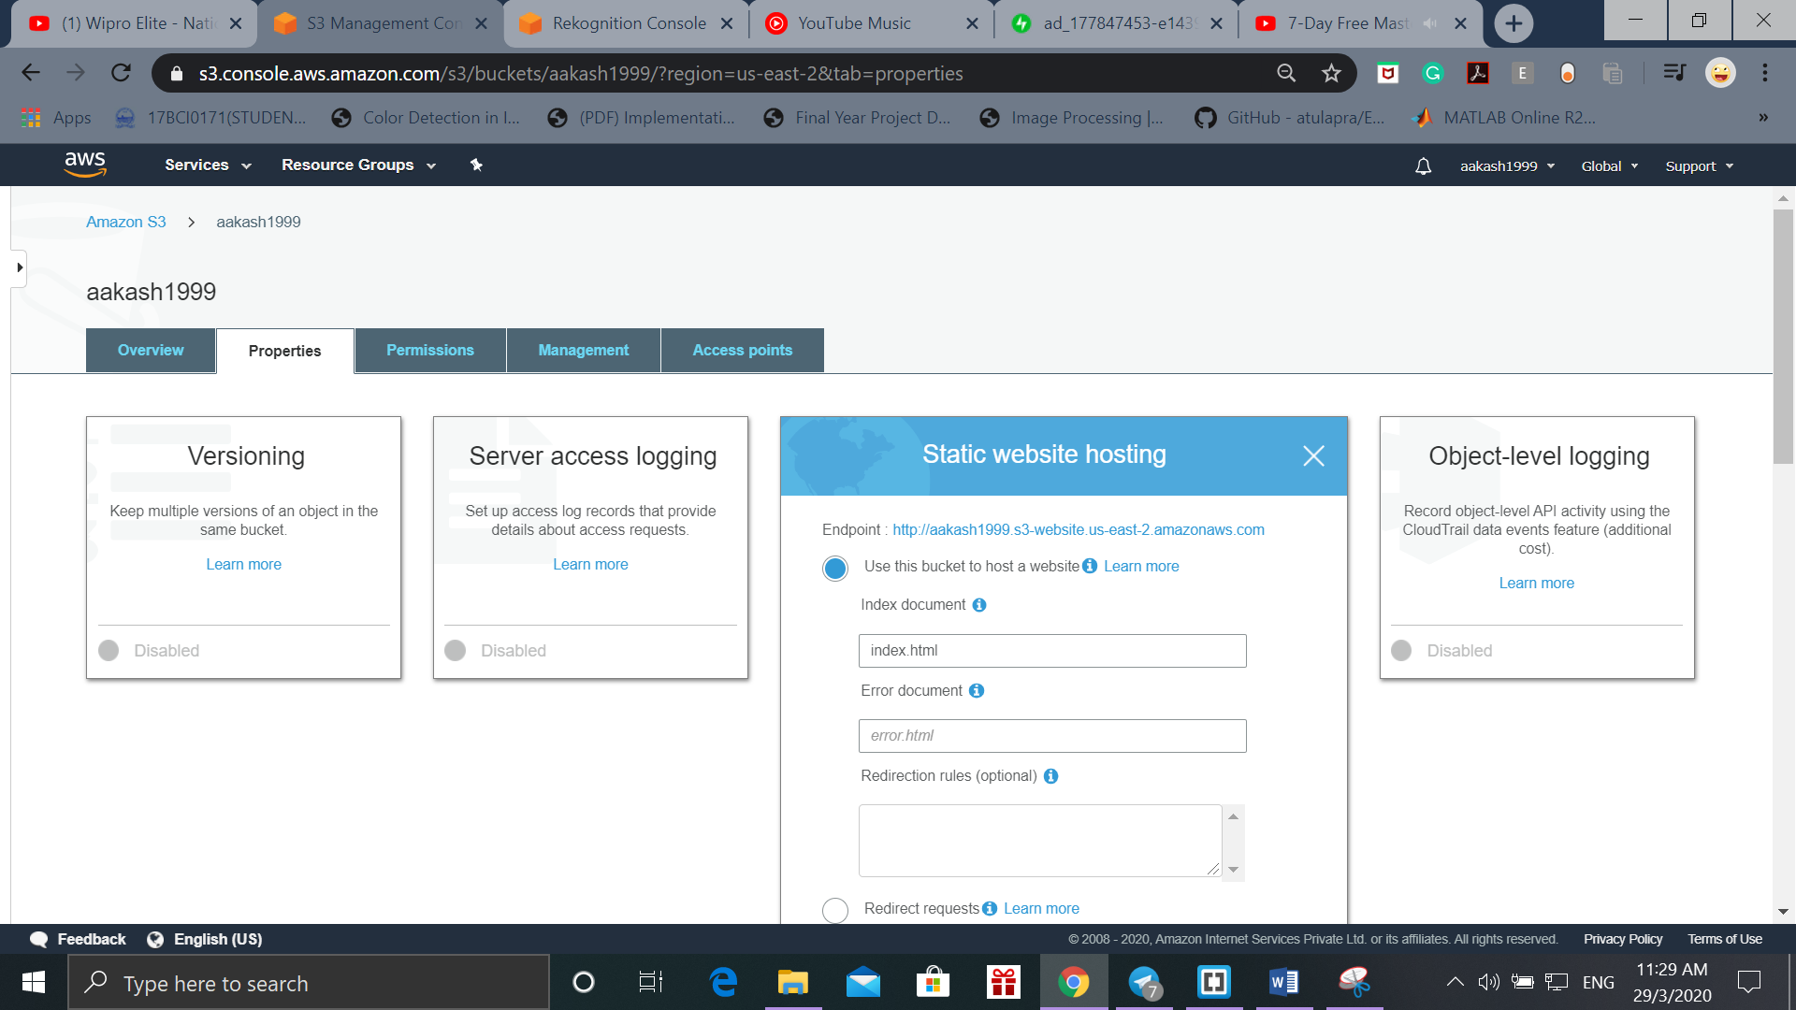

1. Then click on Server access again and then choose endpoint.

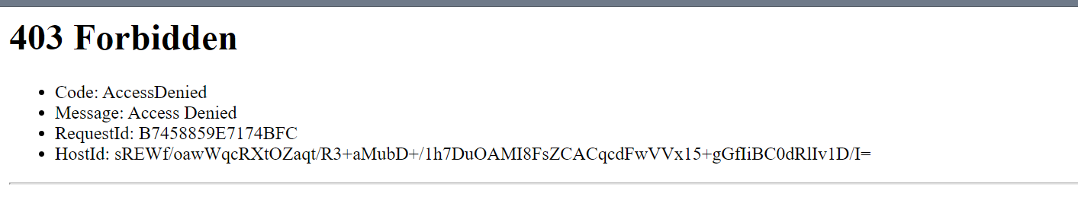

This Forbidden is because we disabled public access for the bucket and the object and so for that we go to Permissions tab and edit the Block public access and confirm that.

Now we need to make the file public also. For that choose the file (index.html) and click on Make Public.

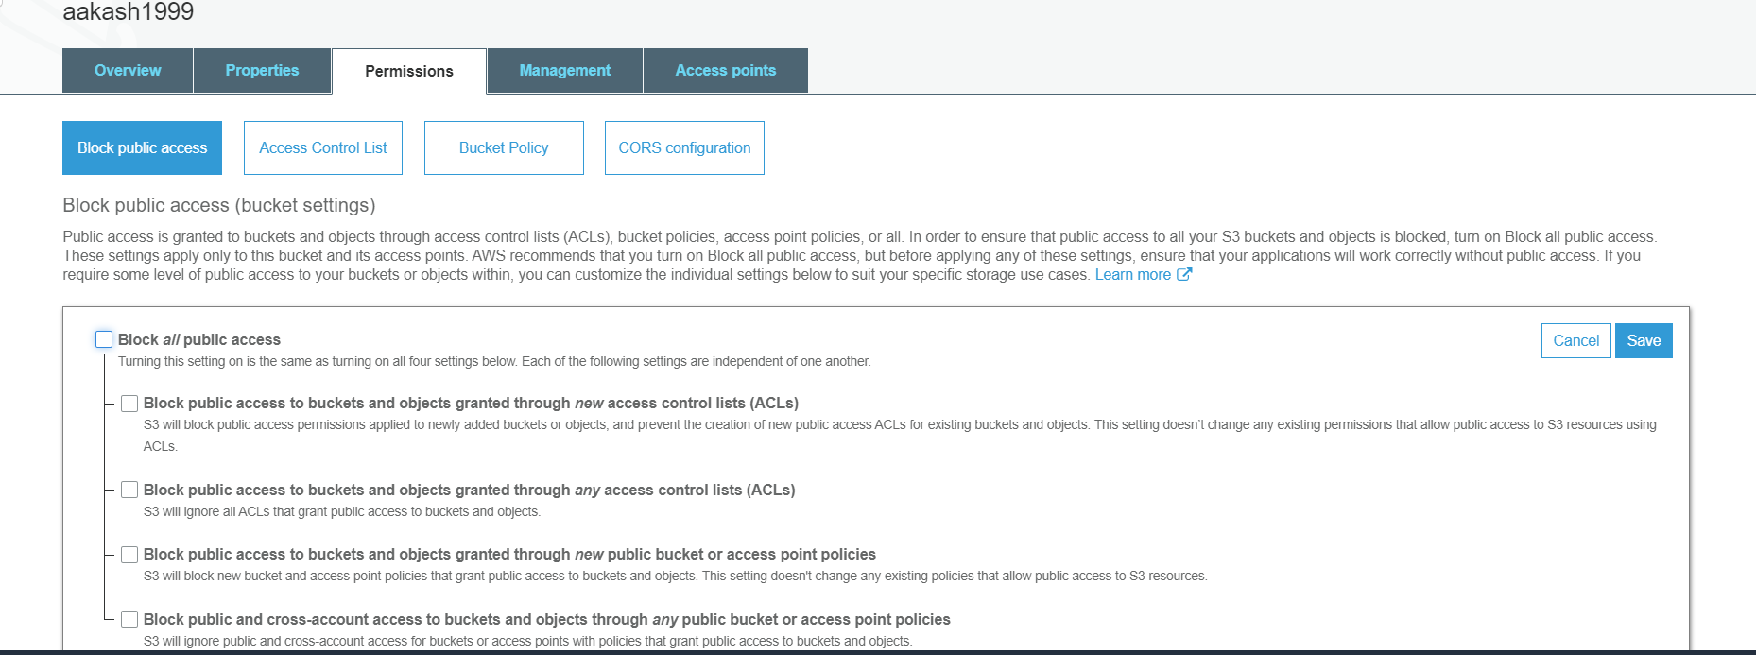

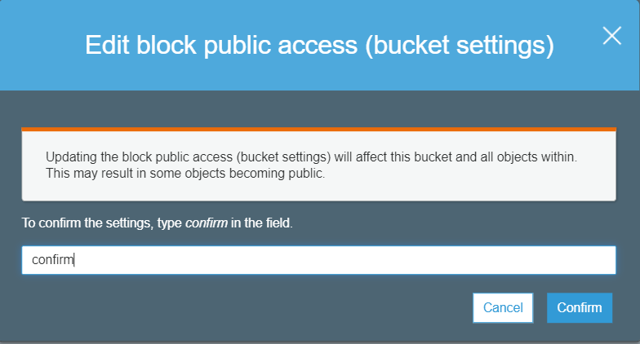

Once the bucket’s access is changed



Making the file/object public

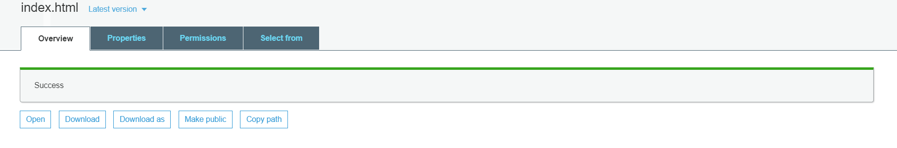

Now reload the page and we can see the contents of index.html.

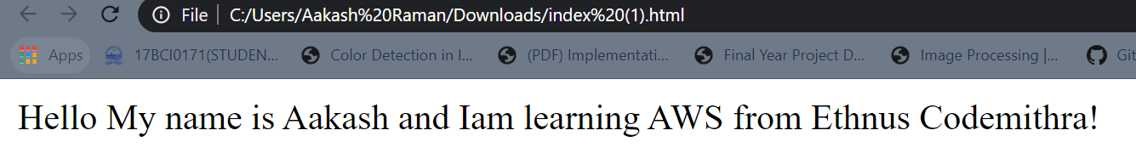

**Day-6(VPC):**

1. Choosing VPC from Networking and Content Delivery under Services

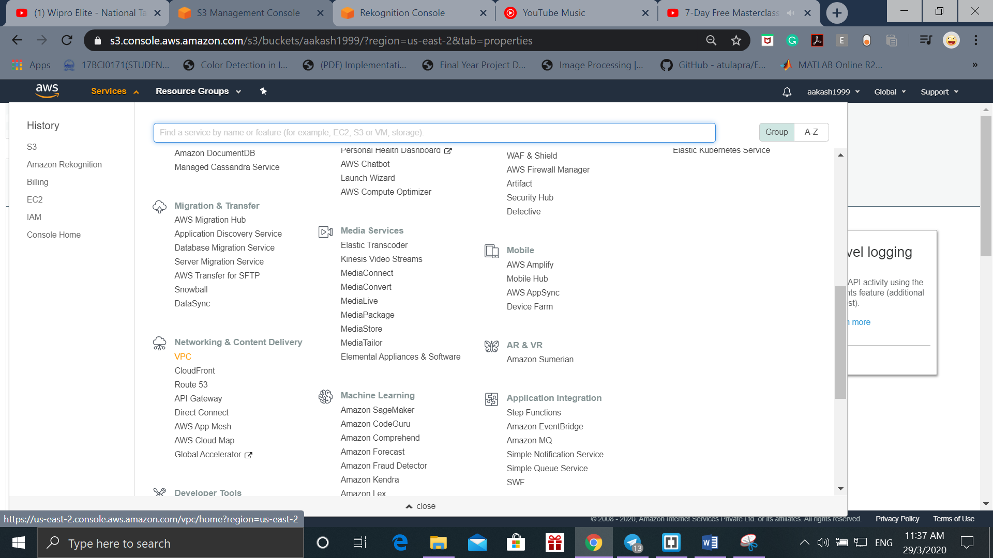

1. The VPC Dashboard for Ohio is shown below. Only 1 VPC is present in Ohio.

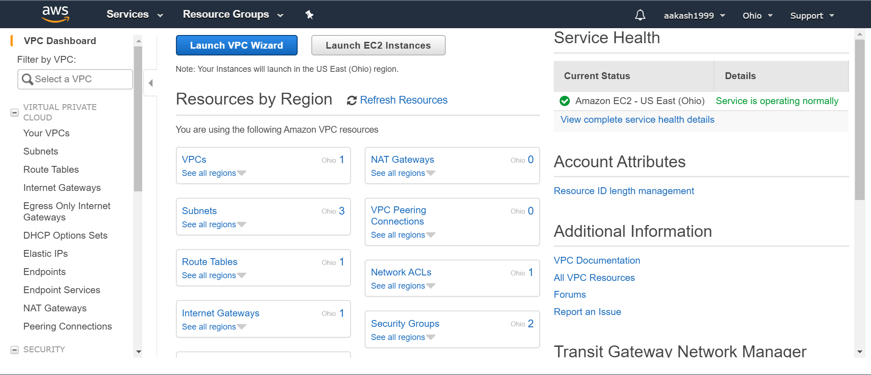

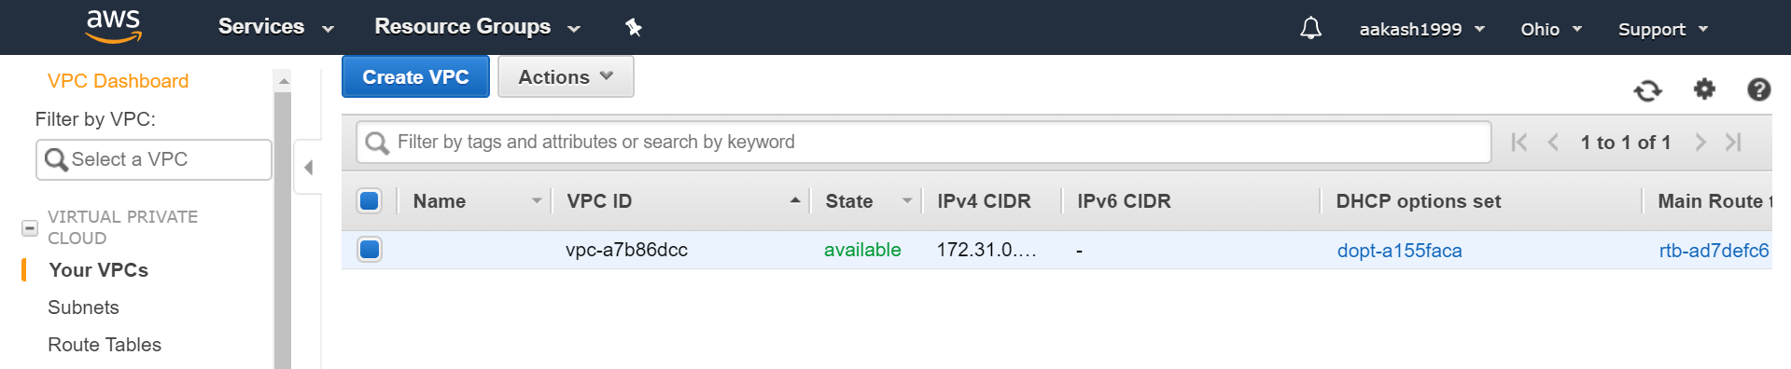

1. The IP Address of this VPC is from the CIDR block(Classless Inter Domain Routing) as shown below.

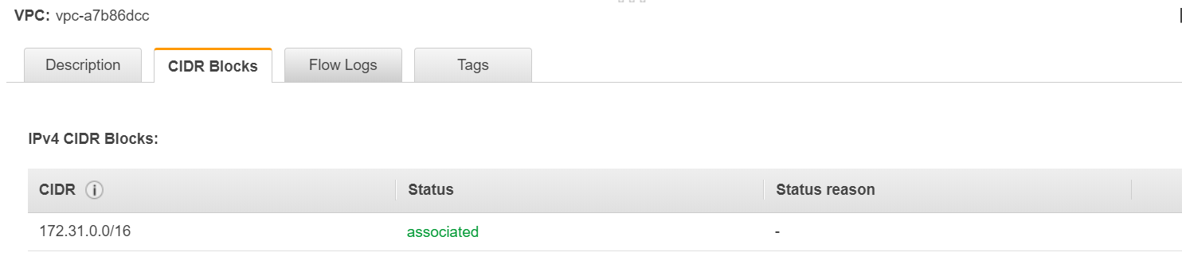

Each VPC is divided into multiple subnets.

1. To view the Subnets we click on the Subnet tab and check the Availability Zones for that Subnet. Subnet is a process of dividing one network into multiple networks.

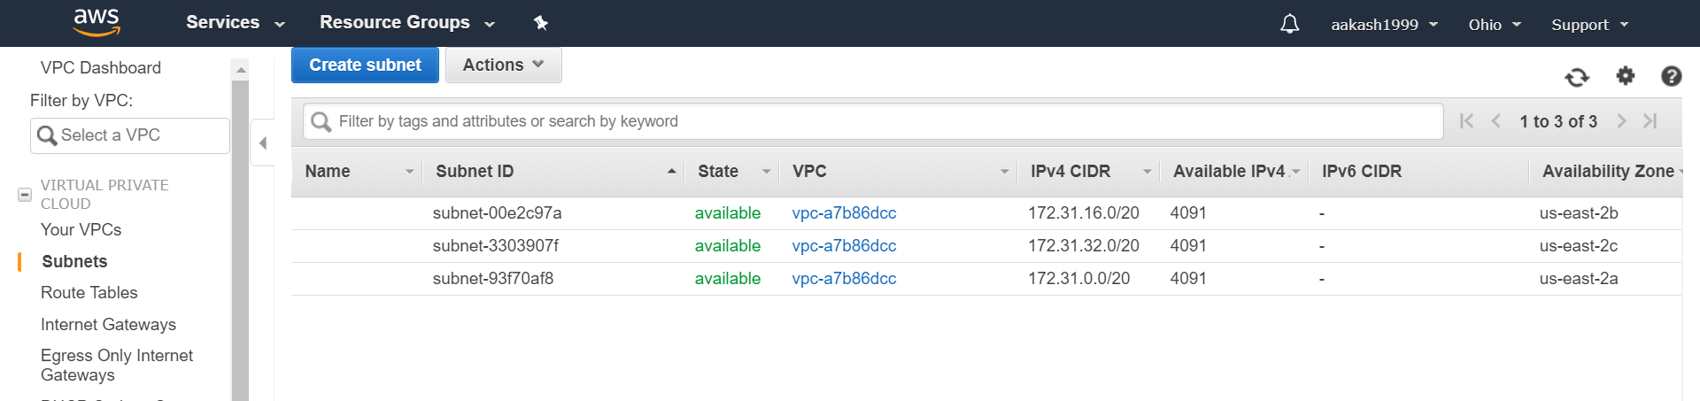

1. Click on the instance and go to instance setting and attach IAM Role.

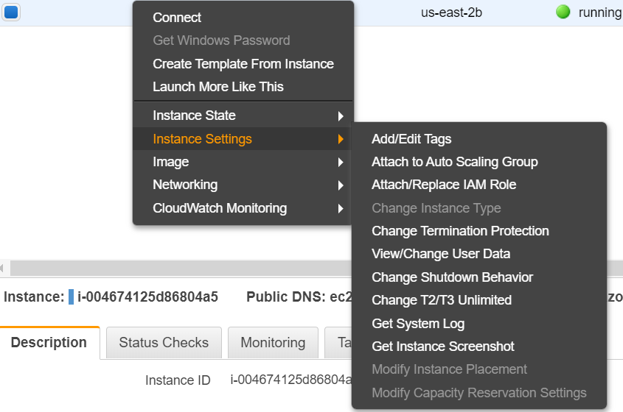

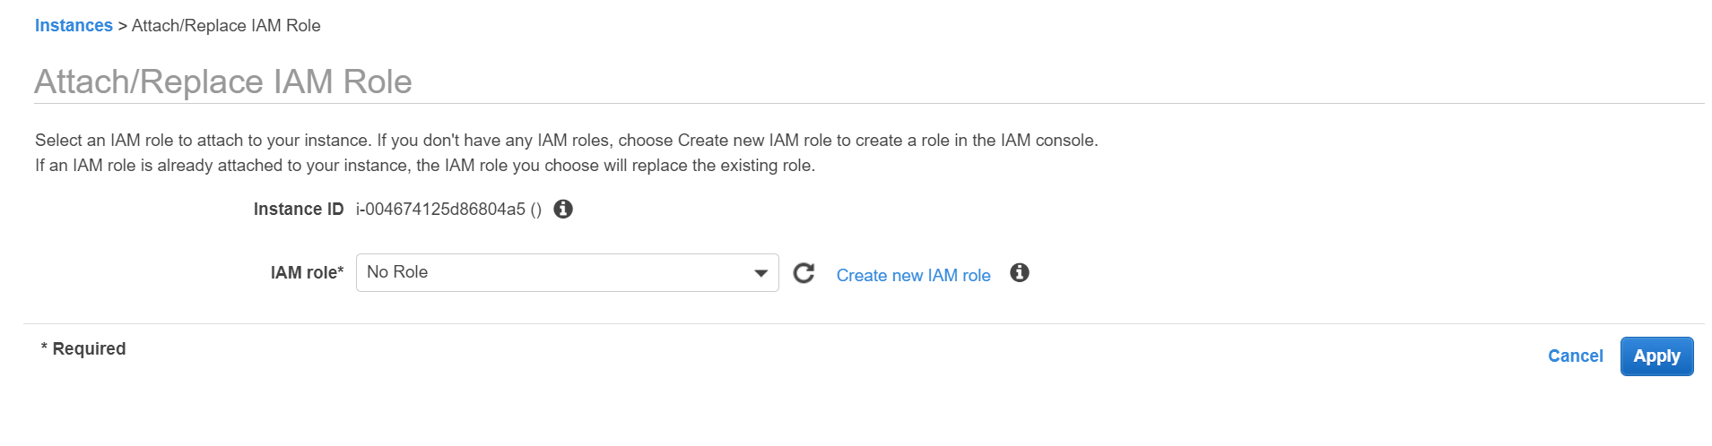

1. Now we must create a new IAM Role. Click on “Create new IAM role” and then “Create Role”. Then choose EC2. Then write s3 and choose s3fullaccess. Skip the Tags section and add your role name. Then choose the role and Create Role. After which assign the role to the instance.

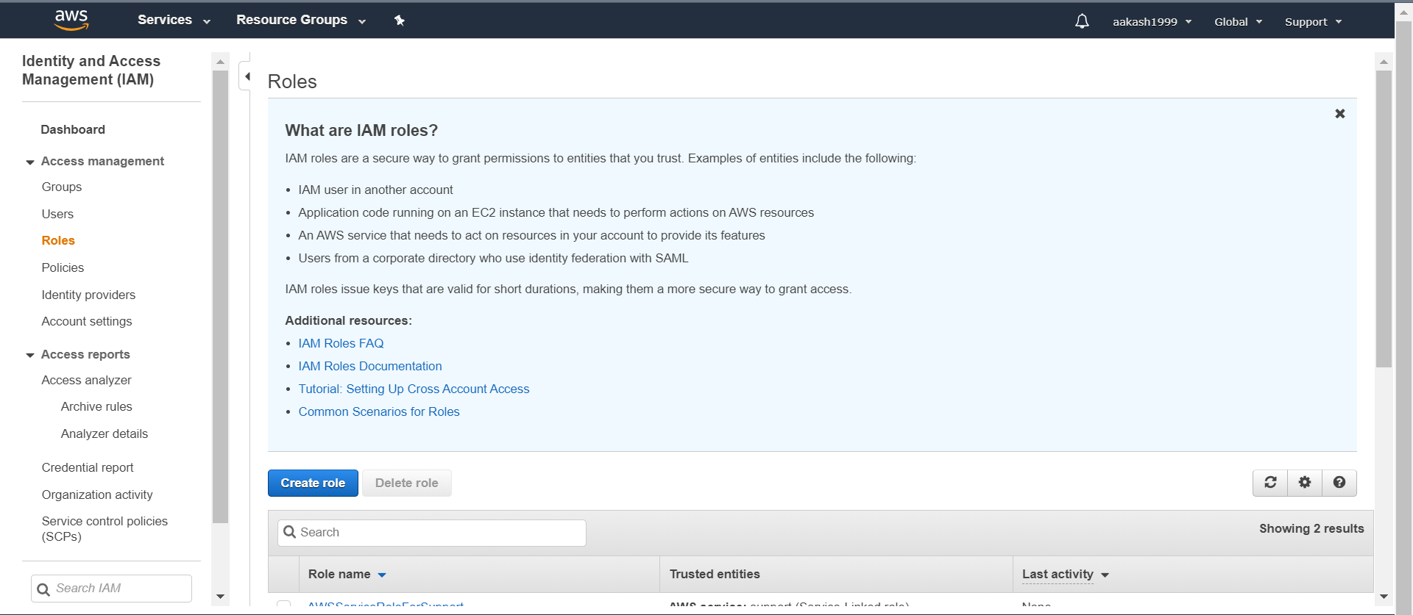

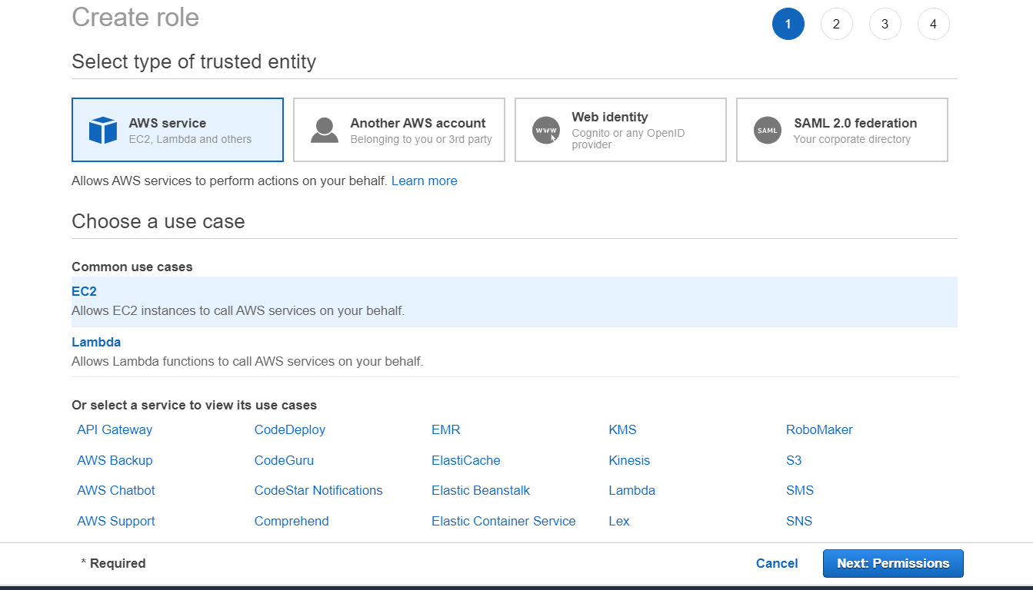

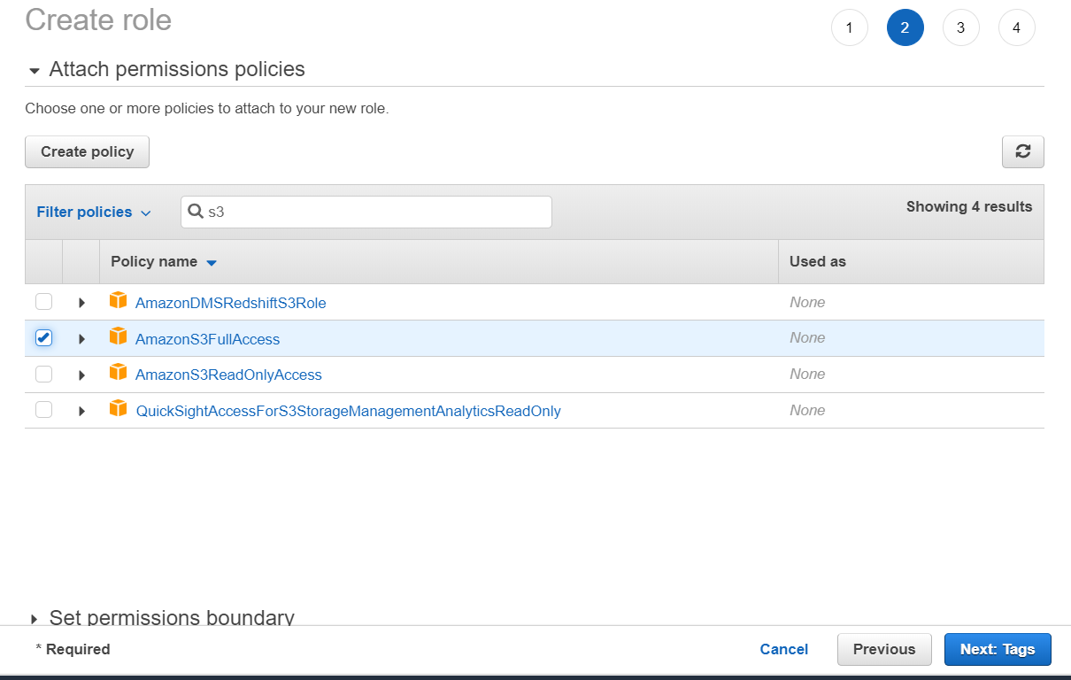

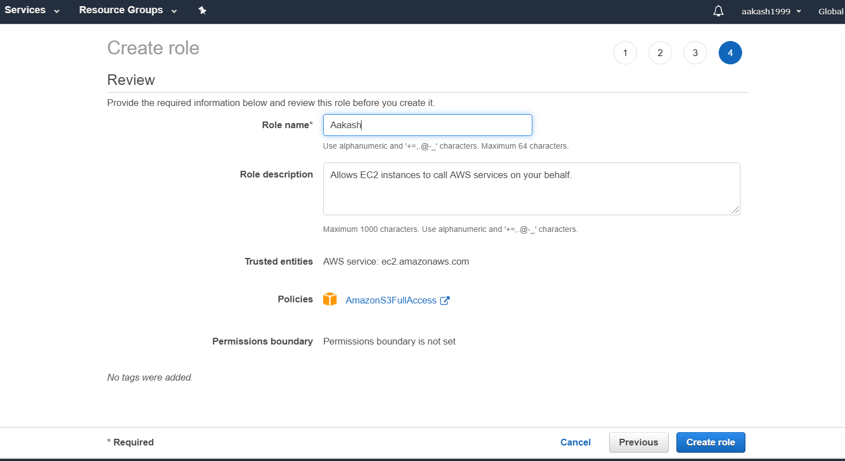

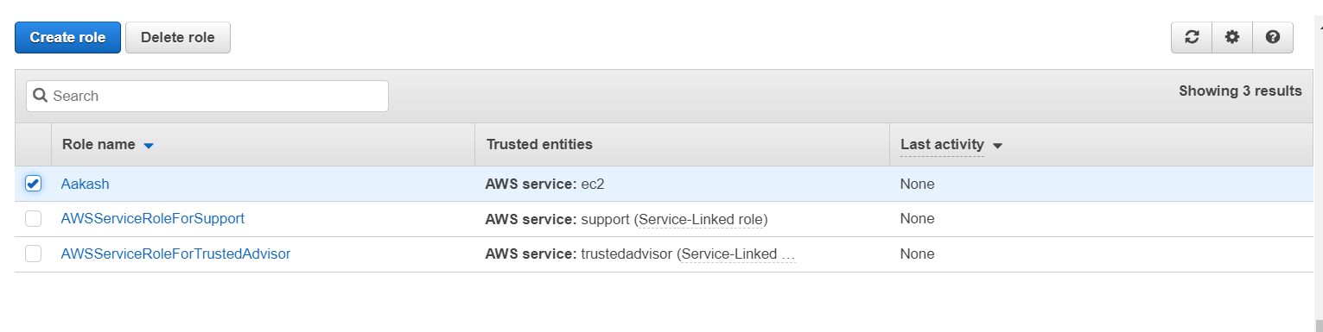

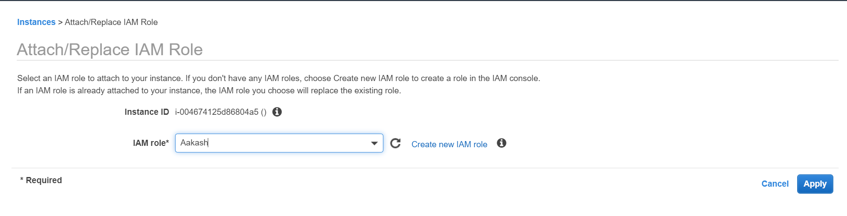

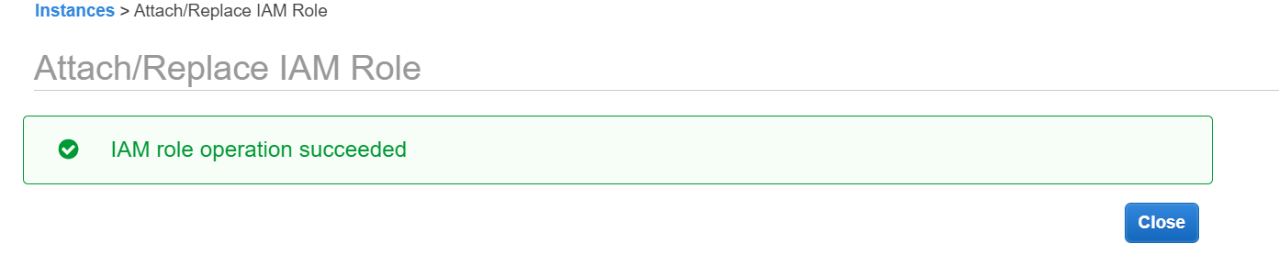

1. Again we will open PuTTy and configure an instance. Now we must install PHP.

*i)sudo yum install php*



*ii)* *curl -sS https://getcomposer.org/installer | php*

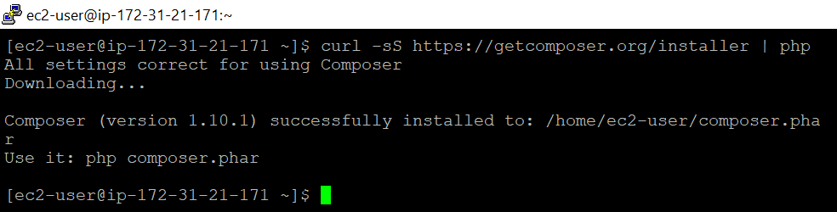

This is to install Composer

*iii)cd/var/www/html and sudo mkdir[make directory] face and cd face and pwd[present working directory]*

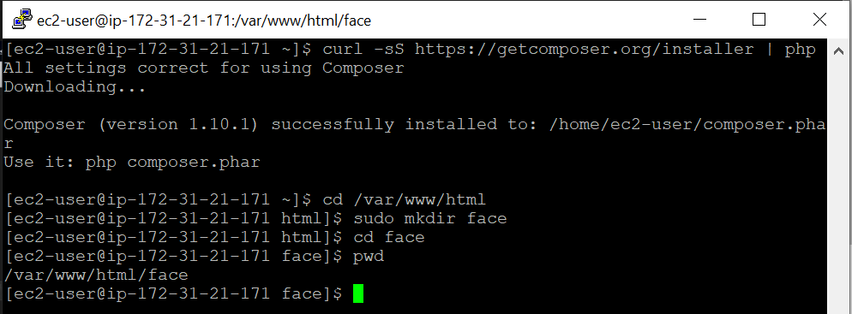

*iv)* *sudo php -d memory_limit=-1 ~/composer.phar require aws/aws-sdk-php*

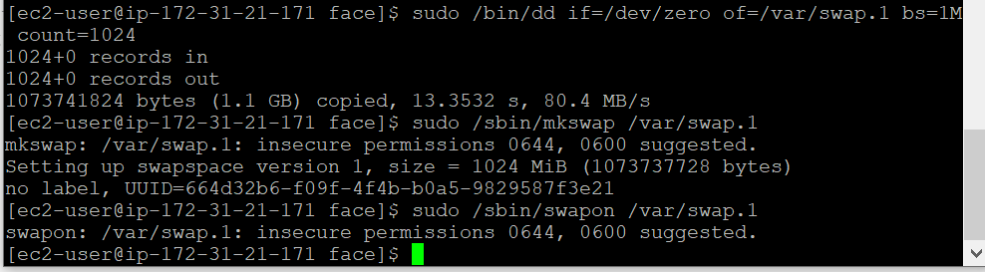

*v)*Now we need to get an image so go to images and choose an image and Open Image in New Tab and copy that link.

We need to use the command “wget”

*sudo wget //Link for Image ending in .jpg*

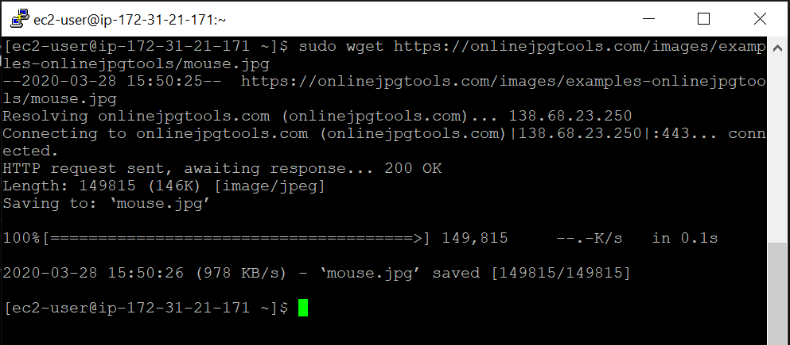

*vi)* If you write “ls” we can see the image file stored.

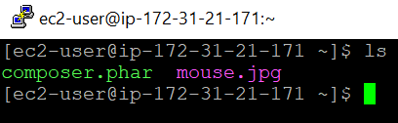

*vii)sudo mv mouse.jpg s.jpg*



This command is used to replace file names.

1. Now we create a PHP file by running the command:

*i)sudo vim index.php* and copy the remaining code

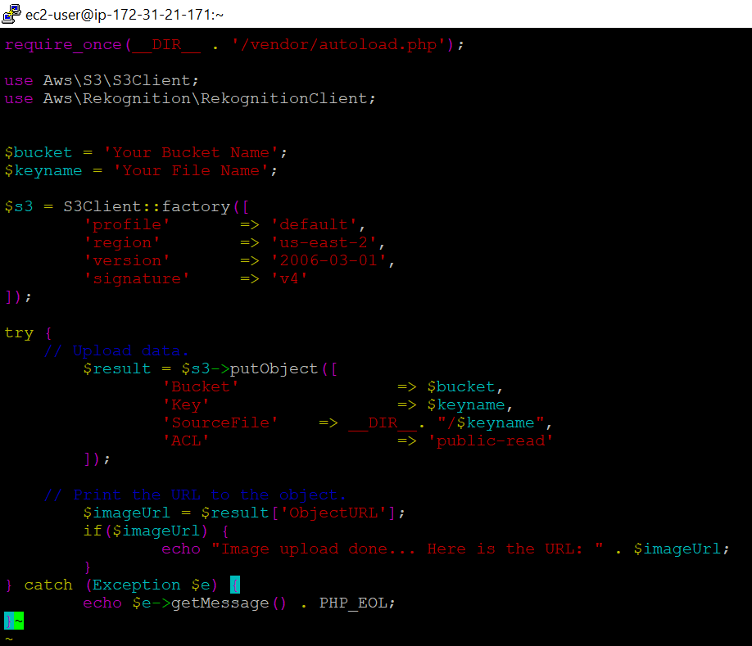

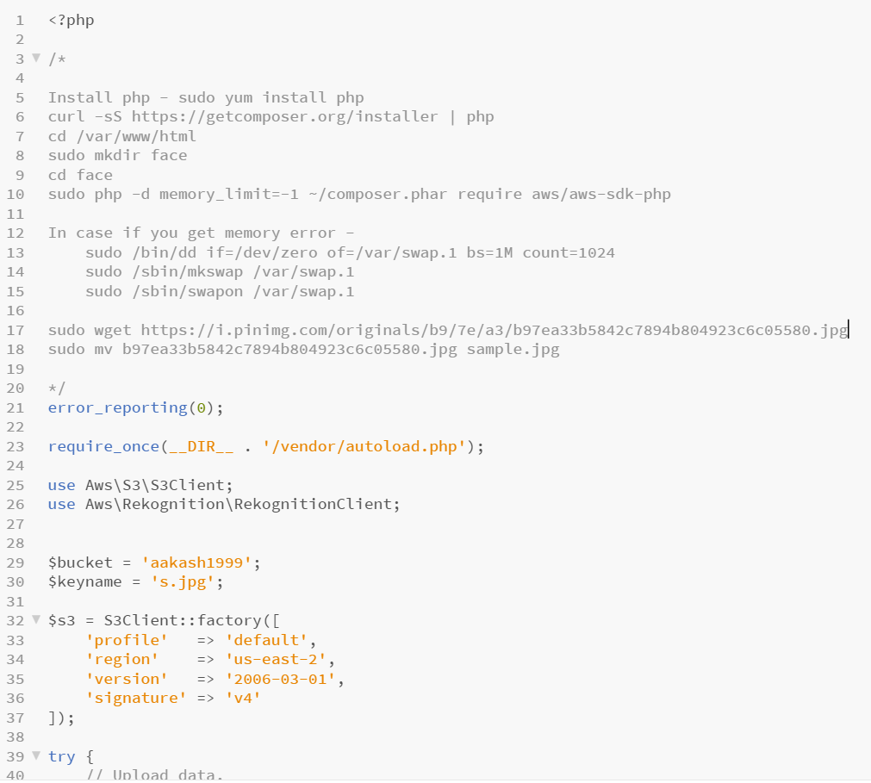

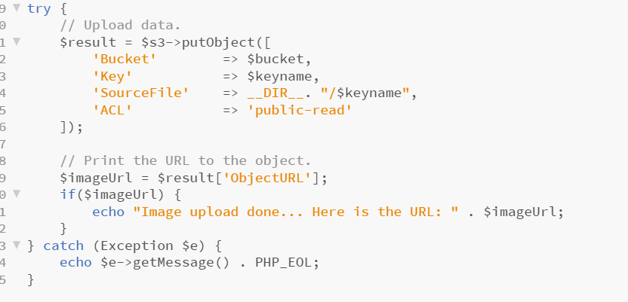

*ii)* Run the *sudo php index.php* command to upload the Image file onto S3



1. Now let’s see the image on S3 it is “s.jpg”

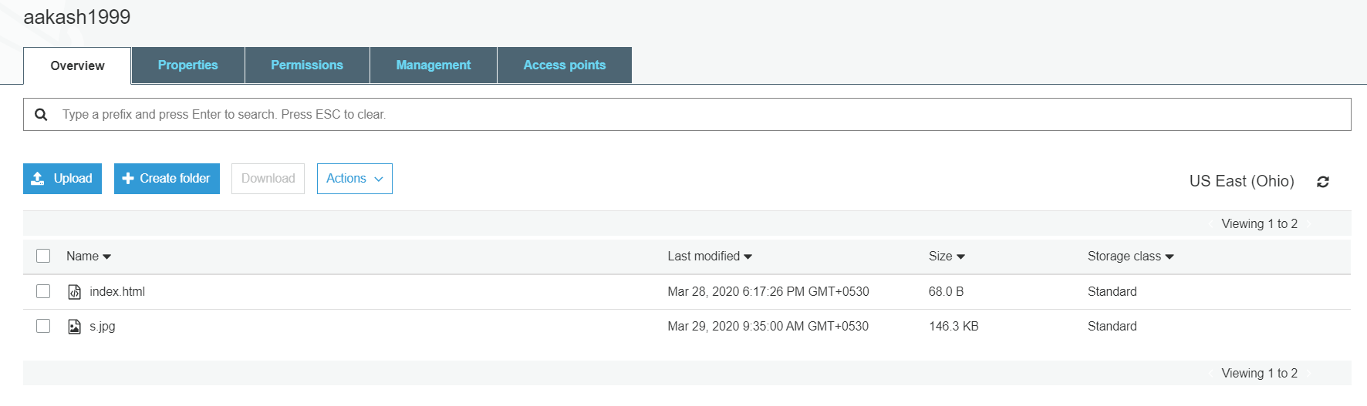

My bucket’s URL for the file:

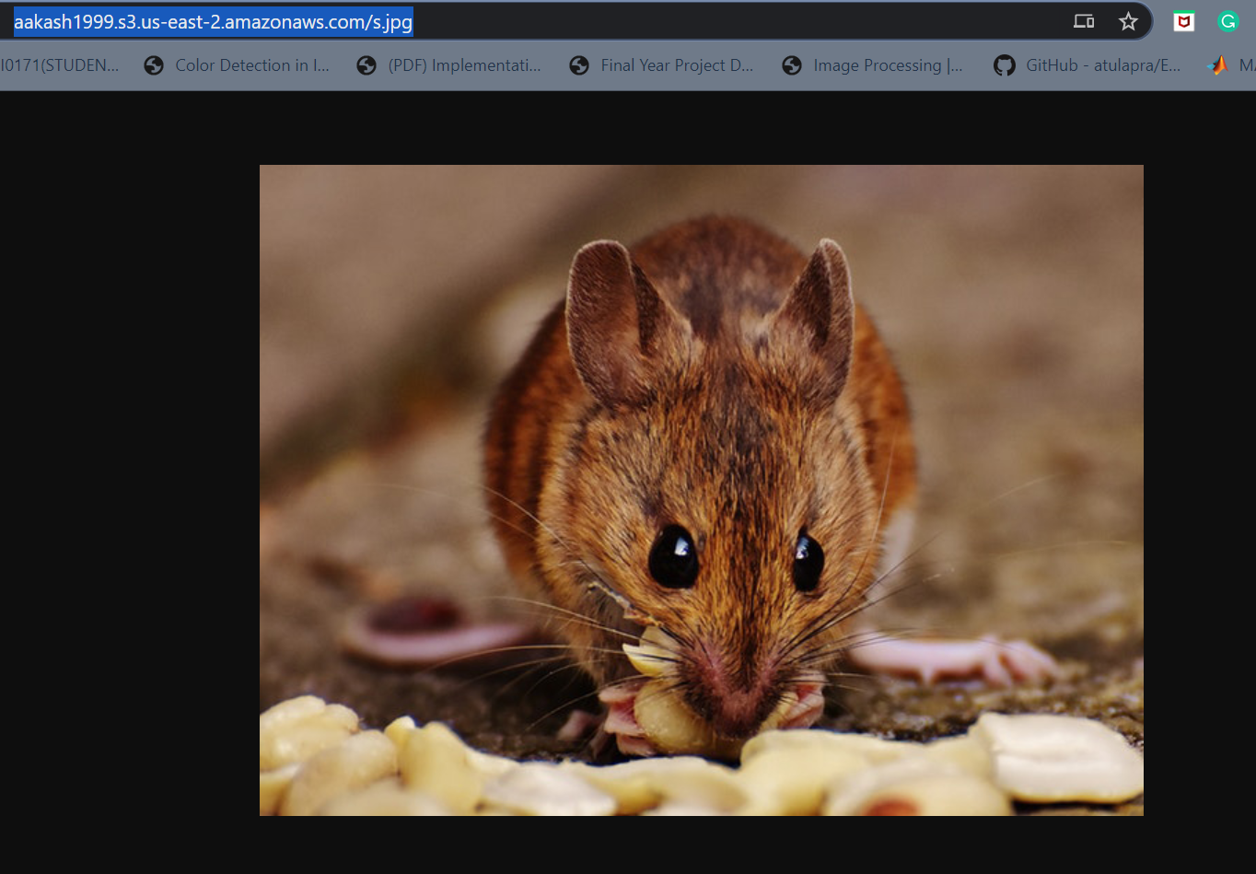

**Day-6(Amazon Rekognition):**

1. Amazon Rekognition Service

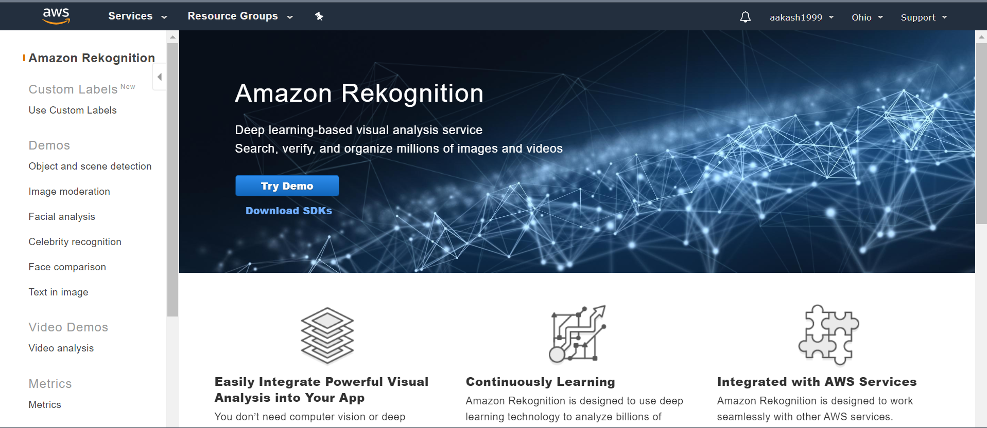

1. Object and Scene Detection on Amazon Rekognition

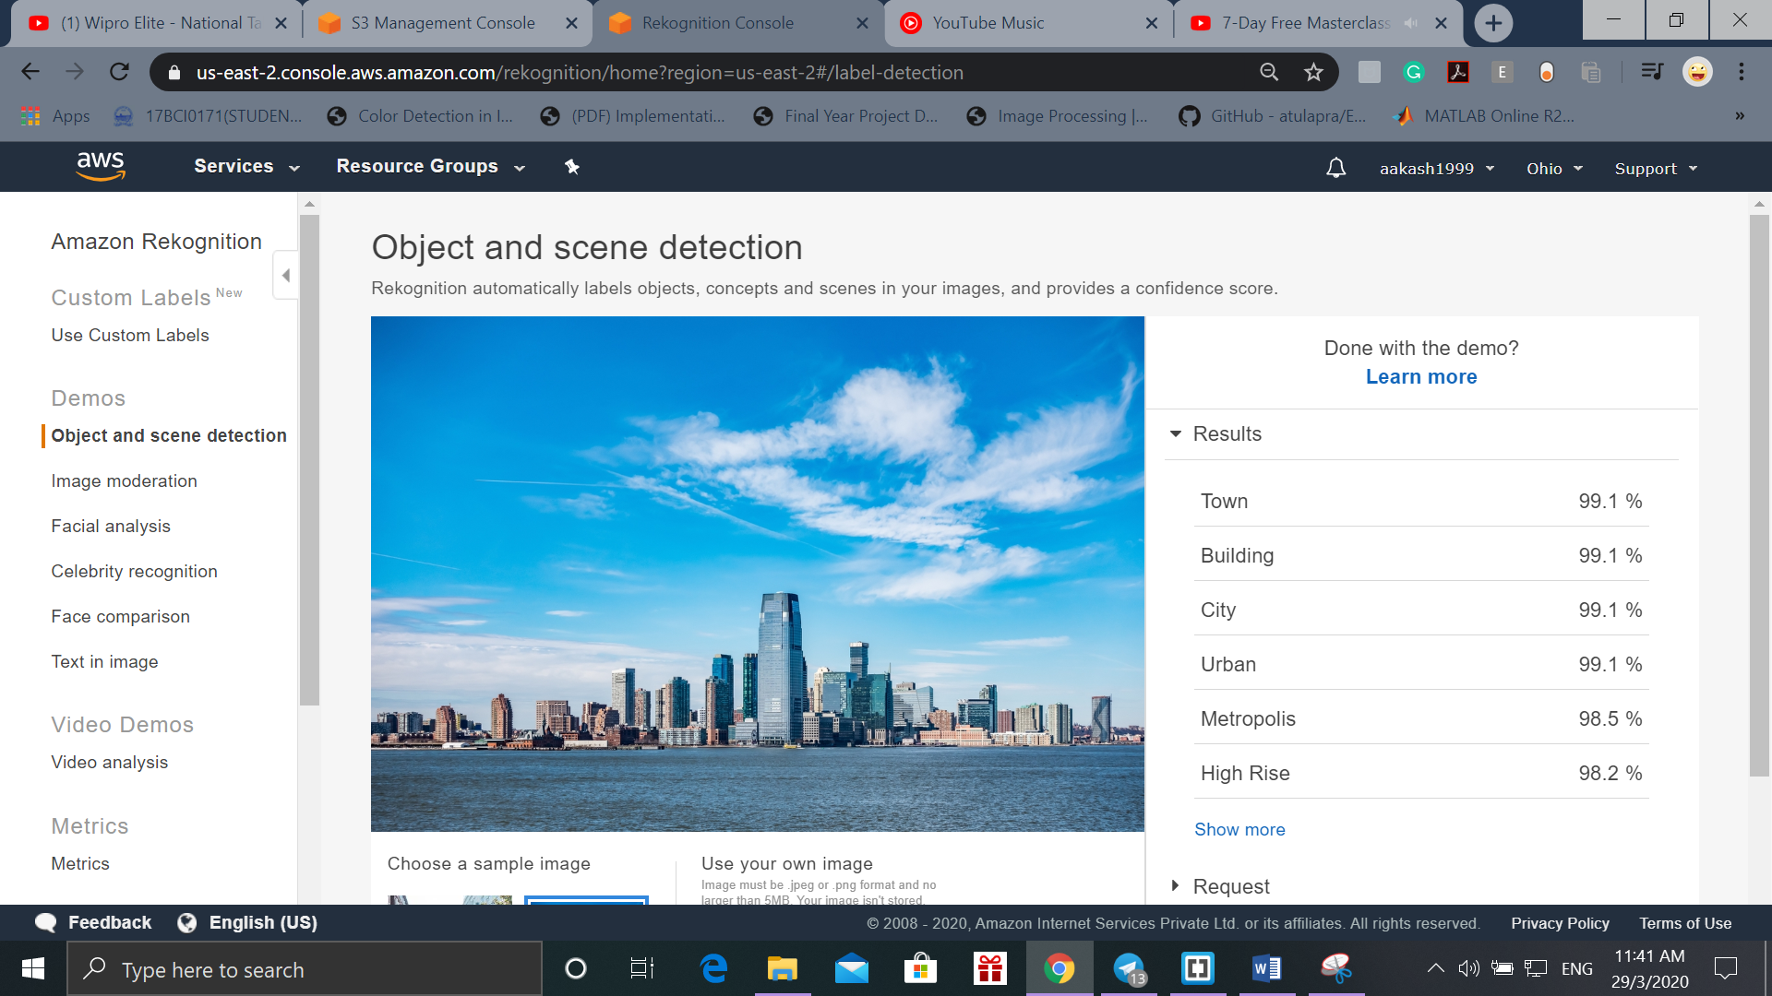

1. Celebrity Recognition on Amazon Rekognition

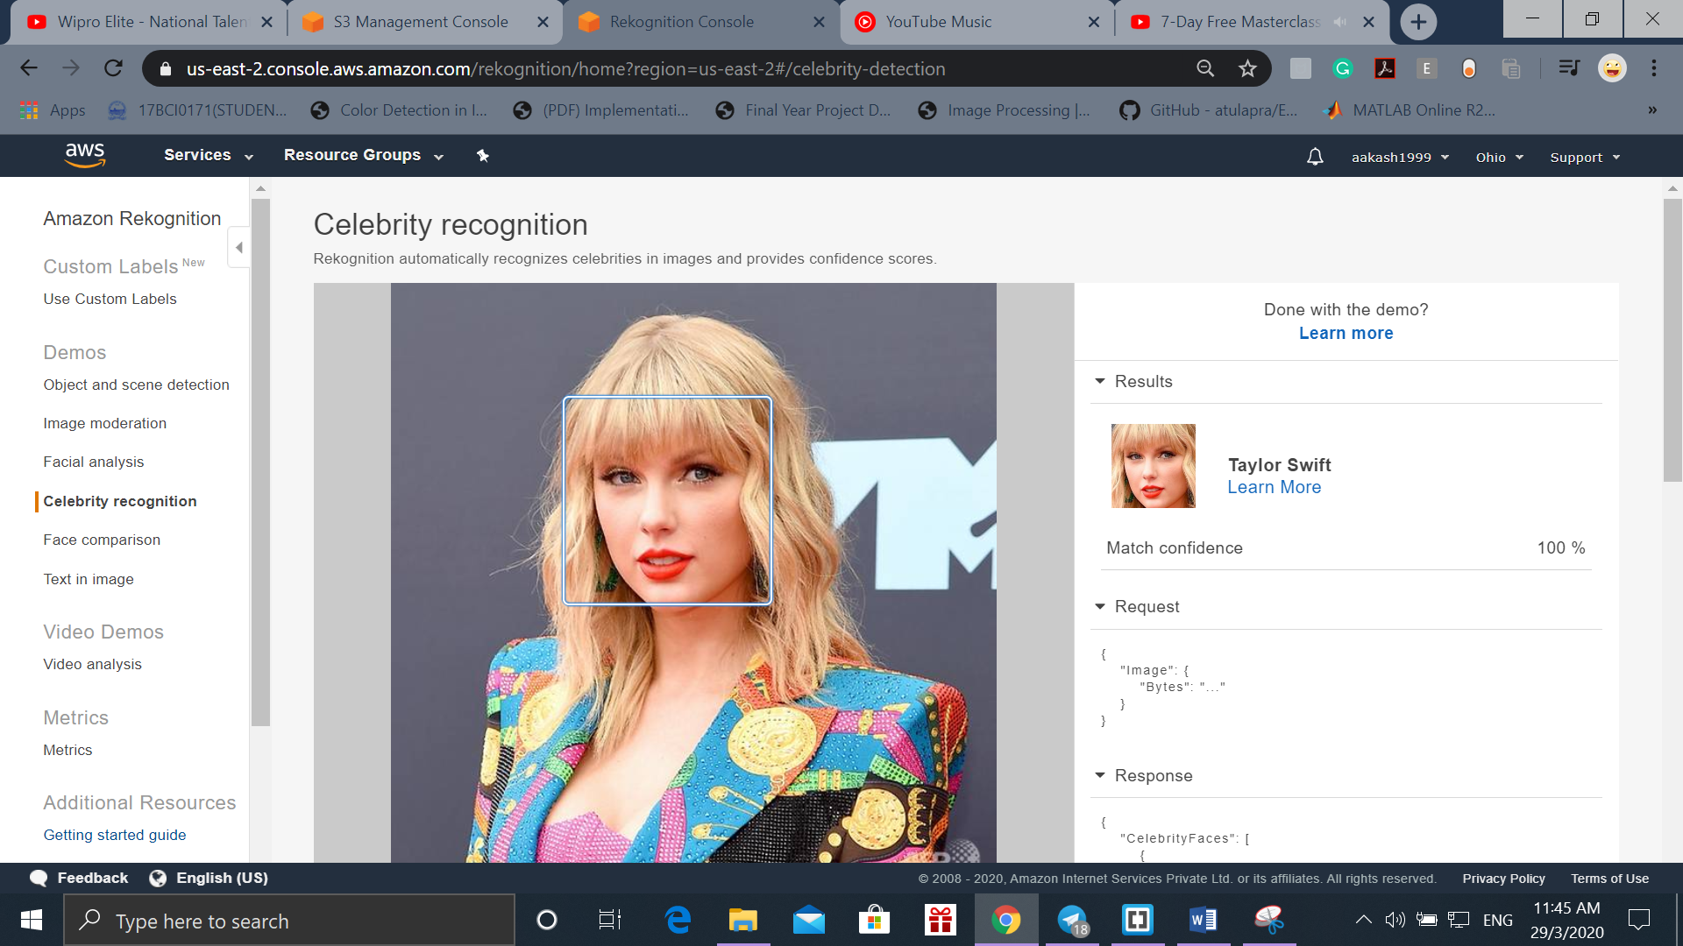

1. Image Moderation on Amazon Rekognition

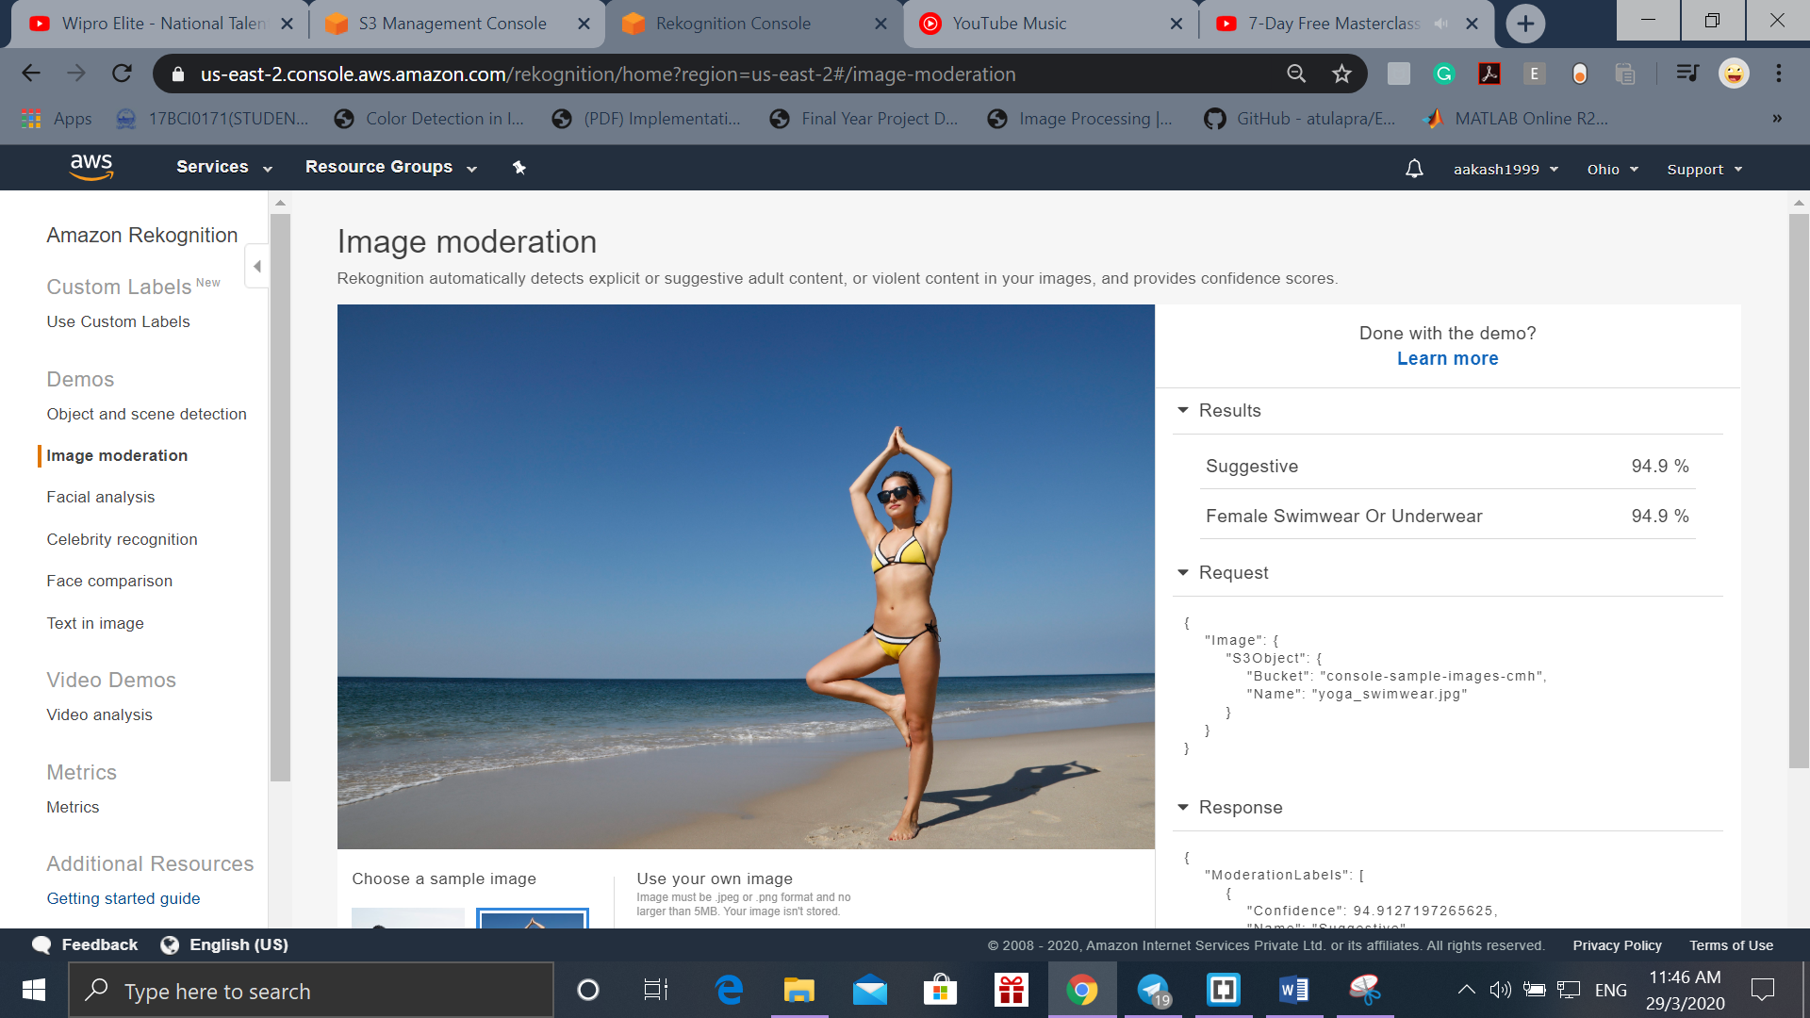

1. Facial analysis on Amazon Rekognition

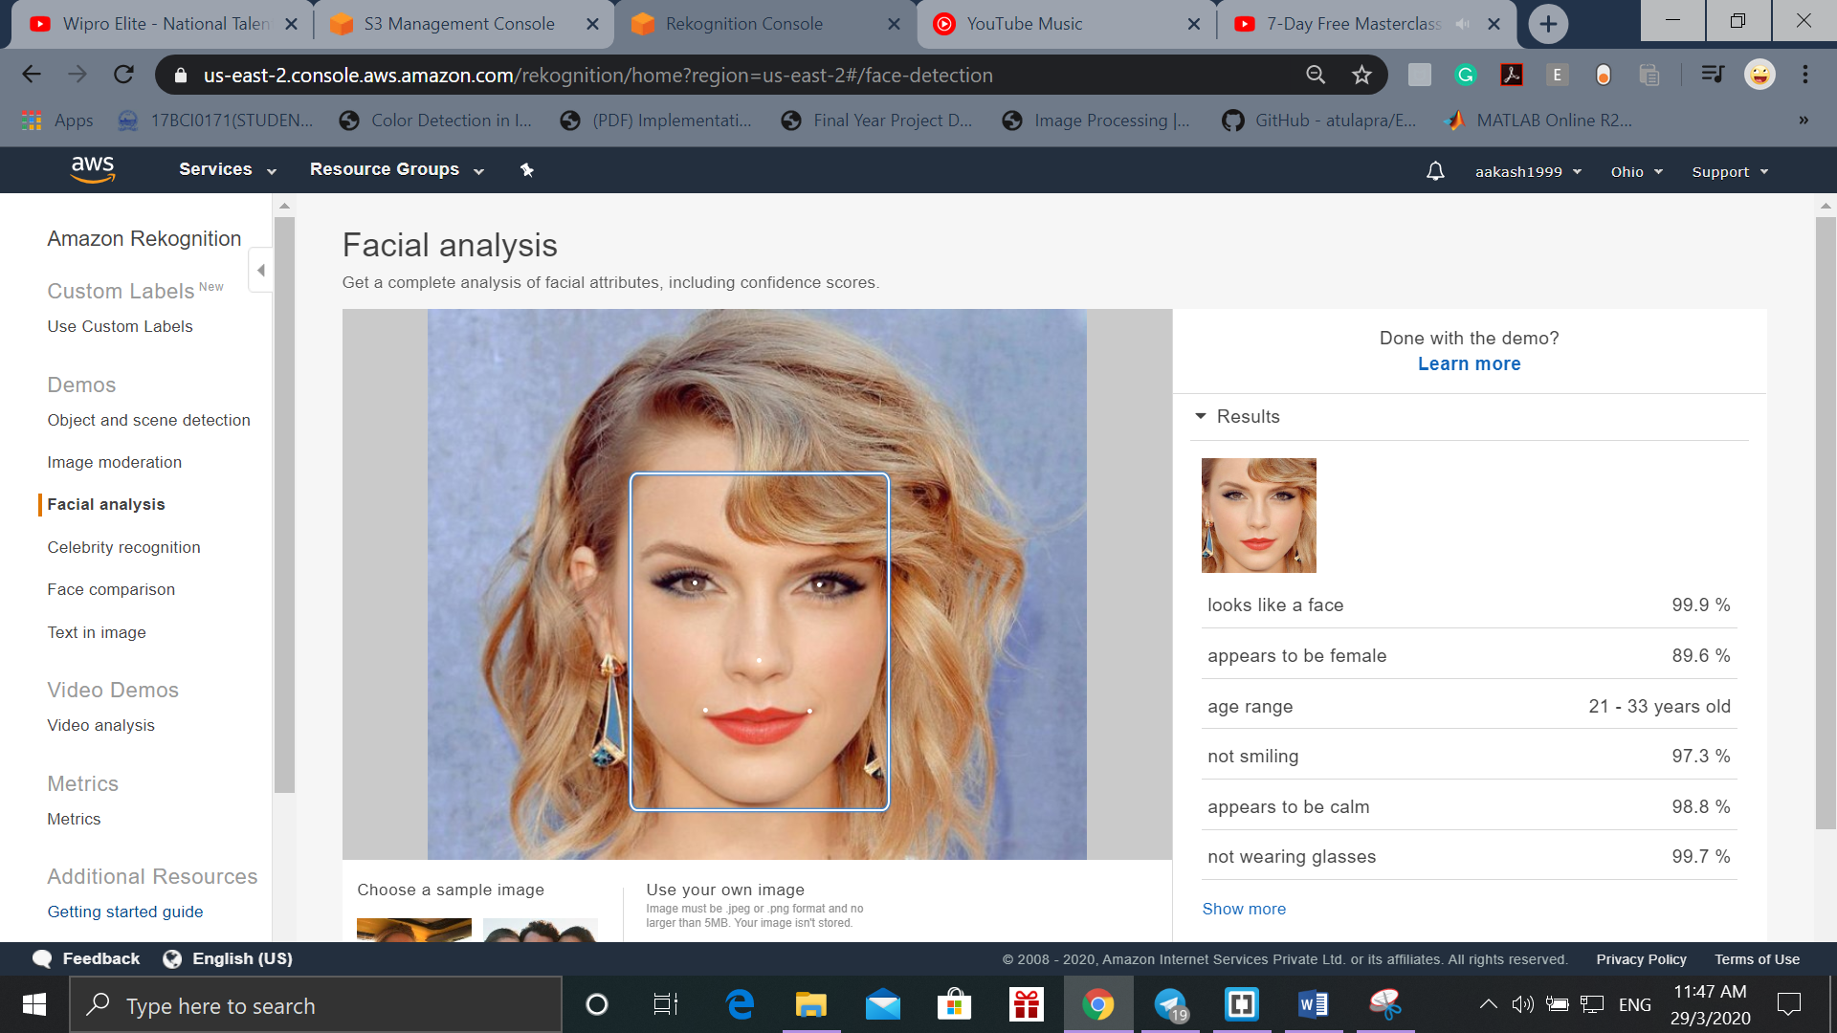

1. Text in Image on Amazon Rekognition

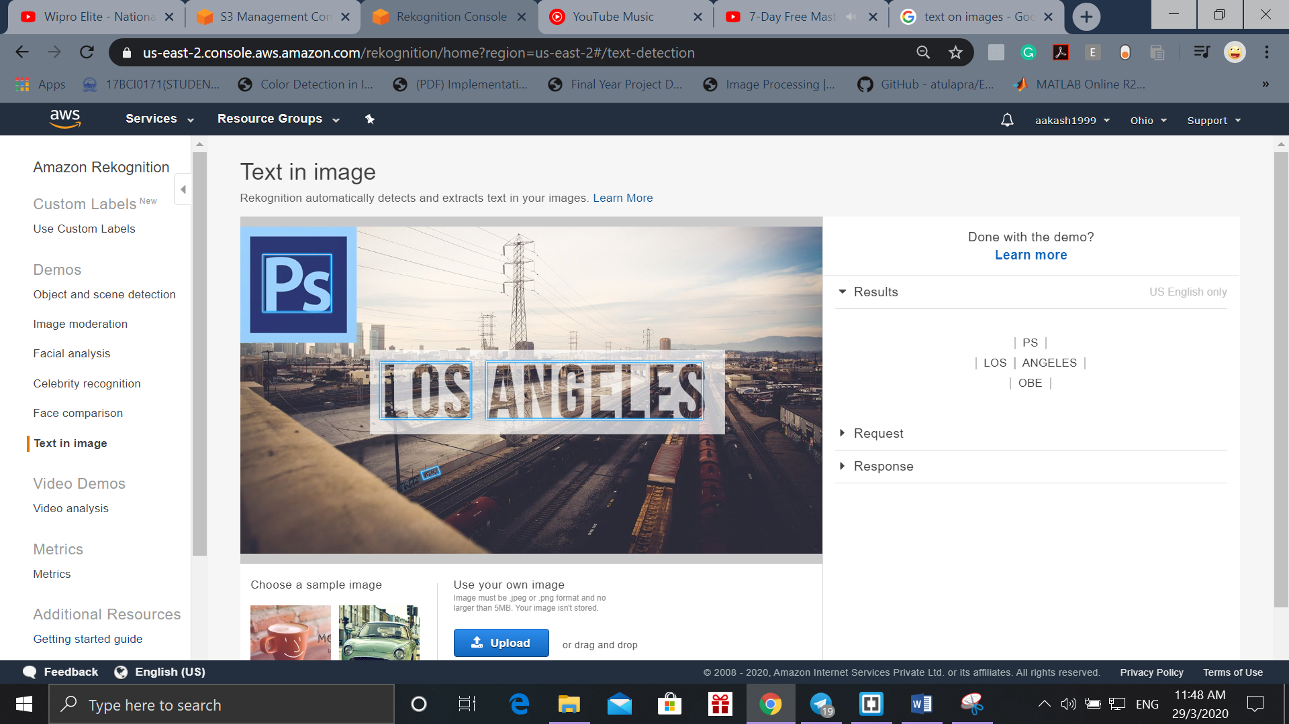

1. Face Comparison on Amazon Rekognition

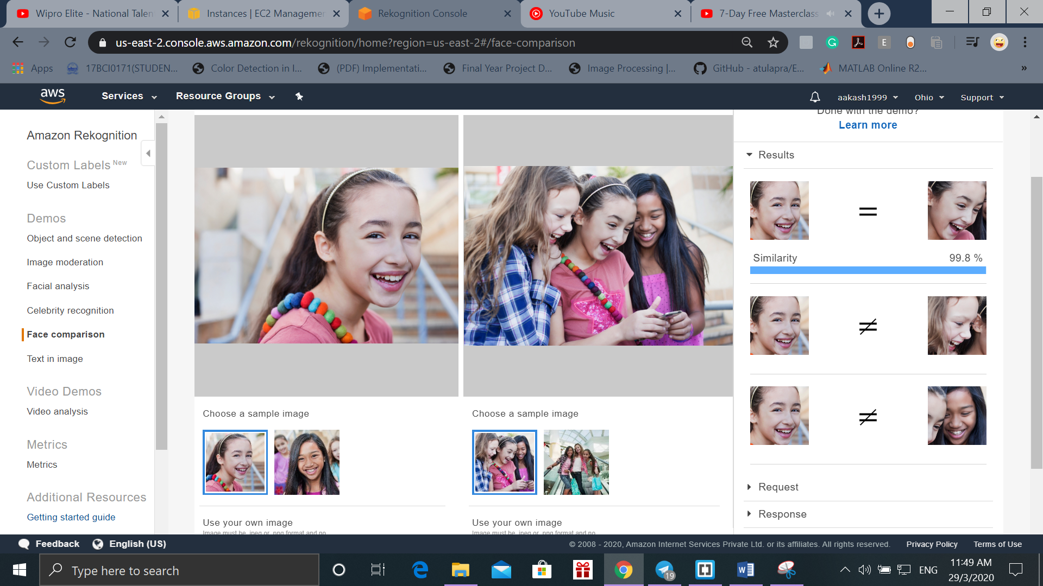

1. Now we will integrate Rekognition with EC2

For that we repeat the steps with the updated Index.php code.

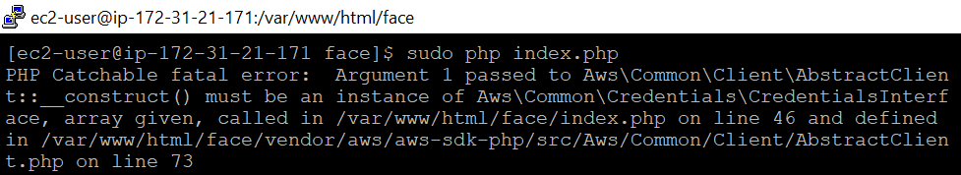

I am getting the above error when proceeding. Hence, I could not link EC2 and Rekognition.

The updated index.php code is as given below:

